|  |
| --- |
| **Al-Aqsa University** |
| **Faculty of Computers and Information Technology** |
| **Networks and Mobile Technology Department** |



**Developing a application for mobile phones as a store for selling household and hand-made products by productive families**

**تطوير تطبيق للهواتف النقالة كمتجر لبيع المنتجات المنزلية واليدوية الصنع من قبل العائلات المنتجة**

**A graduation project submitted in partial fulfillment of the requirements for the degree of Bachelor of Networks and Mobiles Technology**

**Prepared By:**

**Mohammed Sharif Al-Sharif Suleiman Atef Abu Jazzar**

**Tariq Ziad Siksik Osama Nasser Othman**

**Supervisors:**

**Dr. Hassan Dawoud**

**Eng. Sahar Abu Al-Khair**

**Gaza - Palestine**

**July 2022**

# **Thanks, and appreciation**

Our team members, would like to extend our thanks and appreciation to the teaching staff at the Faculty of Computers and Information Technology at Al-Aqsa University for their tireless efforts in delivering the educational message and providing service and aid to us during the four years we spent inside the university, so that they did not hesitate for a moment in dealing with us without providing assistance and giving instructions And advice for launching and working in the world of electronic fields. Finally, we hope in the near future to provide an opportunity to deal and work alongside you in this field. Thank you.

# **Abstract**

Many people in the Gaza Strip are looking for people who manufacture local, national products, which are for example (national foods, clothes, home furniture, souvenirs ... etc.), and these people face difficulty in reaching the people concerned in the Gaza Strip. On this subject and the opposite side, there are several families that manufacture and prepare these products in order to improve their financial situation and provide them with a source of income, but on the other hand they face a problem in marketing these products so that they cannot deliver advertisements for these products to the largest possible number of people, and here Our role, as the owners of the project, comes to solve this problem by launching a Application that is represented as an electronic store and its name is Palestinian home Store, so that this name represents the Palestinian heritage things in all its forms, so that the majority of the products on the App are of Palestinian origin. The purpose of this initiative is to be social rather than profitable, so that this results in improving the social standing of the families that produce these products in the local community, and also improving their financial situation by delivering their products to the largest number of people by marketing them through our store.

**الملخص**

**الكثير من الناس في قطاع غزة يقومون بالبحث عن اشخاص يصنعون المنتجات المحلية الوطنية التي تتمثل في كونها على سبيل المثال عبارة عن (مأكولات وطنية ، ملابس ، اثاث منزلي ، تحف تذكارية ... الخ)، و يواجه هؤلاء الاشخاص صعوبة في الوصول الى الاشخاص المعنين في هذا الموضوع و الجانب المقابل تكون هناك عدة عائلات تقوم بتصنيع و اعداد هذه المنتجات من اجل تحسين وضعها المالي و توفير مصدر دخل لها لكن في المقابل تواجه مشكلة في تسويق هذه المنتجات بحيث لا يستطيعون ايصال اعلانات هذه المنتجات الى اكبر عدد ممكن من الناس ، و هنا يأتي دورونا كأصحاب المشروع بحل هذه المشكلة من خلال اطلاق تطبيق إلكتروني يتمثل كمتجر الكتروني و اسمه (البيت الفلسطيني) بحيث يتمثل هذا الاسم بالأشياء التراثية الفلسطينية بكل اشكالها بحيث تكون غالبية المنتجات الموجودة على التطبيق فلسطينية الاصل ، الغاية من هذه المشروع ان تكون اجتماعية اكثر من ان تكون ربحية ، بحيث ينتج عن ذلك تحسين المكانة الاجتماعية للأسر التي تقوم بالإنتاج هذه المنتجات في المجتمع المحلي و ايضا تحسين الوضع المالي لها من خلال ايصال منتجاتها الى اكبر عدد من الناس من خلال تسويقها عبر تطبيقنا البيت الفلسطيني .**

**TABLE OF CONTENTS**

# 1 **Thanks, and appreciation**………………...………………………………………………….……I

2 **Abstract**……….…………….…………………………...………………………………….……. II 3 **Chapter 1** ………………….………………………………………………………….……..……...1

**1.1 Introduction ……...…………………….…..……………………………………………………………………………****12**

**1.2 Introduction to the project:……...……………………. …..…………………………………………………….....…12**

**1.3 Study Problem …………………….……………..…...…..……………………………………………………….……****12**

**1.4 Project Goals ….………….………….…...…………………..……………………………………………………...….13**

**1.5 Project significance…………………………………………………………...….….…****…………………………….…14**

**1.6 Proposed System……………………………………………………………….……………………………………...….15**

**1.7 project boundaries. ….…………….…………………………………………………………………………………..…16**

**1.8 Gant chart. ….……………………………………………………………………………………………..….…………..17**

**1.9 Summary. ….………………………………………………………………………………………………….…………..18**

4 **Chapter 2**..……….....................…....……................................................................................……19

**2.1 Introduction.…..……..……………………….................................................................................................................20**

**2.2What is a mobile phone?.…..……..………………………...............................................................................................20**

**2.3 What are mobile applications? ……...…………….…....…….………….……………………………………….………20**

**2.4 What are programming languages?.…………………………………..……………………………..……….…………** **20**

**2.5 What is the language of filters?..........................................................................................................................................21**

**2.6 What is the Firebase?……...………………....................……………………………………….…….….……………....****22**

**2.7 Azeez App.….…….……………………….................................................................................................................……****24**

**2.8 Sender App.…..……..……………………….............................................................................................................……****25**

**2.9 Jumia website. ….…….…………………………………………………..................................................................……27**

**2.10 Comparing previous studies……………….... …………………………. …………………………….................……****28**

**2.7 Summary. ….…………………………………………………………………………………………….………..….…...22**

5 **Chapter 3** …………………………………………………………………….....….................……23

**3.1 Introduction.….…….…………………………………………………….................................................................……24**

**3.2 Project methodology ……………….........................................................................................................................……****29**

**3.3 Summary. ….……………………………………………………………………………..……………….……...............31**

**6 Chapter 4…………………………………………………………....................….................……32**

**4.1 Introduction.….…….……………………………………………………..……………………...................................33**

**4.2 Models.….…….…………………………………………………………….……………….........................................33**

**4.3 System Analysis. …..……..……………………………………………….………………..……………….................35**

**4.4 system testing. ….…….………………………………………….………………………………….............................47**

**4.5 System results……………………………………….....………………………………………………........................48**

**4.6 Summary. ….……………………………………………………………………….………………….………….......113**

**7 Chapter 5……………………………………….......................…...................................……114**

**5.1 Introduction.….…….……………………….........................................................................................................115**

**5.2 Assumptions.….…….……………………….........................................................................................................****115**

**5.3 Evaluation.…..…..…..………………………......................................................................................................116**

**5.4 Summary. ….………………………………………………………………….………………………….............120**

**8 Chapter 6………………………………….......................….................…………………...…121**

**6.1 Introduction.….…….………………………...........................................................................................................122**

**6.2 Recommendations.….…….………………………..................................................................................................122**

**6.3 Future business. …..…..…..………………………..................................................................................................122**

**6.4 Project conclusions. …..…..…..………………………............................................................................................123**

**9 References**.......**……………………….......................….................………………..….…...…114**

**10 Supplements………………….......................….................……………….…….................…115**

**List Of Figures**

* Figure 1.5: Application Diagram.
* Figure 3.1: Agile methodology
* Figure 4.3.1.1: user diagram.
* Figure 4.3.1.2: Seller diagram.
* Figure 4.3.1.3: Delivery diagram.
* Figure 4.3.1.4: Admin diagram.
* Figure 4.3.2.1: User Login diagram.
* Figure 4.3.2.2: Seller Login diagram.
* Figure 4.3.2.3: Delivery Login diagram.
* Figure 4.3.2.4: Admin Login diagram.
* Figure 4.3.3.1: User Chart diagram.
* Figure 4.3.3.2: Seller Chart diagram.
* Figure 4.3.3.3: Delivery Chart diagram.
* Figure 4.3.3.4: Admin Chart diagram.
* Figure 4.2.1: System Design.
* Figure 4.5.1.1: Main interface.
* Figure 4.5.2.1: User Cerate account.
* Figure 4.5.2.2: User sign in.
* Figure 4.5.2.3: User main interface.
* Figure 4.5.2.4: User select Seller.
* Figure 4.5.2.5: user select product.
* Figure 4.5.2.6: Add to Cart.
* Figure 4.5.2.7: Ordered the Product.
* Figure 4.5.2.8: Delete the Order.
* Figure 4.5.2.9: select user location.
* Figure 4.5.2.10: Select new Location.
* Figure 4.5.2.11: Location in Map.
* Figure 4.5.2.12: confirmed the Order.
* Figure 4.5.2.13: user menu.
* Figure 4.5.2.14: Orders.
* Figure 4.5.2.13: Order Information.
* Figure 4.5.2.14: Archive Order.
* Figure 4.5.2.15: Order Information.
* Figure 4.5.2.16: Search Seller.
* Figure 4.5.2.17: Select new Location.
* Figure 4.5.2.18: Sign Out.
* Figure 4.5.3.1: seller Registration.
* Figure 4.5.3.2: seller sign on.
* Figure 4.5.3.3: seller Main interface.
* Figure 4.5.3.4: Add new category.
* Figure 4.5.3.5: Add new category.
* Figure 4.5.3.6: add information for category.
* Figure 4.5.3.7: Add an item.
* Figure 4.5.3.8: Add new items.
* Figure 4.5.3.9: Add new items.
* Figure 4.5.3.10: Add item information.
* Figure 4.5.3.11: items.
* Figure 4.5.3.12: Items information.
* Figure 4.5.3.13: Seller menu.
* Figure 4.5.3.14: New order.
* Figure 4.5.3.15: Order processing.
* Figure 4.5.3.16: Archived order.
* Figure 4.5.3.17: Archived Order.
* Figure 4.5.3.18: Seller Log out.
* Figure 4.5.4.1: Delivery Registration.
* Figure 4.5.4.2: Delivery sign on.
* Figure 4.5.4.3: Delivery Main Interface.
* Figure 4.5.4.4: Available Order.
* Figure 4.5.4.5: Receipt of the order.
* Figure 4.5.4.6: waiting order.
* Figure 4.5.4.7: order in the way.
* Figure 4.5.4.8: Delivery path in Map.
* Figure 4.5.4.9: Order not Delivered.
* Figure 4.5.4.10: order delivery.
* Figure 4.5.4.11: Delivery way in Map.
* Figure 4.5.4.12: Archive order.
* Figure 4.5.4.13: Order Delivered.
* Figure 4.5.4.14: cash balance delivery.
* Figure 4.5.4.15: Delivery Log out.
* Figure 4.5.5.1: Admin log in.
* Figure 4.5.5.2: Control panel web main Interface.
* Figure 4.5.5.3: Active user account.
* Figure 4.5.5.4: disable user account.
* Figure 4.5.5.5: User disable Account.
* Figure 4.5.5.6: Active user account.
* Figure 4.5.5.7: Active seller Account.
* Figure 4.5.5.8: disable seller account.
* Figure 4.5.5.9: Delivery active account.
* Figure 4.5.5.10: disable Delivery account.
* Figure 4.5.5.11: Admin log out.
* Figure 5.3.1: Usability Evaluation.
* **List of Tables:**
* Table 1.1: Gant chart
* Table 3.1: Comparing proposed system
* Table 5.3.1: Usability Evaluation
* Table 5.3.2: Functional Evaluation
* Table 5.3.3: Performance Evaluation
* Table 5.3.4: Performance Evaluation
* Table 6.1: Icons

**Chapter 1**

**Introduction**

# **1.1 Introduction:**

In the first chapter, we dealt with the introduction to the report, and then we moved to the study of the problem, where we explained the problem and how it can be solved and a schedule was created that simulates the project completion plan

## **1.2 Introduction to the project:**

The idea of the project talks about creating an application for mobile phones in the form of a store that displays handmade and home-made products by individuals and productive families and the application consists of several axes, a part related to the user so that he buys and orders the products displayed on the application and a part related to the seller so that he displays his own products on the application and a part related to the delivery that delivers the orders he receives from the seller and delivers them to the user.

# **1.3 Study Problem:**

As we know, there are many families who have opened their own projects at home and made their own handmade products, but this project quickly fails due to the lack of sales in it. The reason for this is the poor marketing of this product, and the owners of these projects also tried to market these products through platforms social media, but also the number of followers of a page is small and it cannot reach the largest number of people, and here comes our role by marketing these products through our application, which will be a media advertisement covering all areas of the Gaza Strip, and thus the largest number of people will be able to reach it.

**1.4 Project aims and objectives:**

After defining the problem and explaining how it is possible to develop a solution to it, now comes the role of defining the project objectives that must be achieved in order to make the project successful:

1- Working and contributing, albeit in a small way, to reduce unemployment and create job opportunities for families that will provide them with a financial return that improves the economic and social situation of these families and makes them engage and become part of the local community.

2- This consists of reviving the Palestinian folklore through these products that will contain some of them, for example: folk foods, traditional clothes, etc. Some of these products work to revive this heritage in the Palestinian society.

3- In this regard, we are trying to give families the opportunity to obtain a source of income through the sale of their handmade products that are made at home, so that these products are marketed in order to be able to sell them, and also for the owners of the project to obtain profits represented by obtaining a percentage of profit from selling these products in exchange for marketing them.

4- From here comes our role as the owners of the project, so that we will design and develop an application similar to a store that markets hand-made and home-made products for these families, so that this store contains multiple types of usable products (food, drinks, clothes, tools, decorations. Etc.) etc.), and the absenteeism of these products indicates national and local products.

# **1.5 Project significance:**

**The importance of this project is represented in the following points:**

1- Attempting to create job opportunities for families with little income so that they can increase their source of income.

2- Designing an online store based on displaying the products produced by these families and offering them for sale.

3- Saving time and effort on customers by getting these products ready instead of wasting time preparing them or spending time searching for them.

4- Show new marketing methods for these products instead of doing so by selling them on social media or displaying them in the market.

5- Solve the problem of the lack of places to show and sell the products of these families by displaying them in this store.

6- Helping to save money and not costing these families to find a place and pay its rent and also pay taxes and services (water, electricity...etc).

7- Improving the social status of these families by improving their financial situation.

8- The possibility of showing products that were difficult to obtain and buy.

9- Demonstrating the effort and creativity of these families in their products.

# 

# **1.6 Proposed System:**

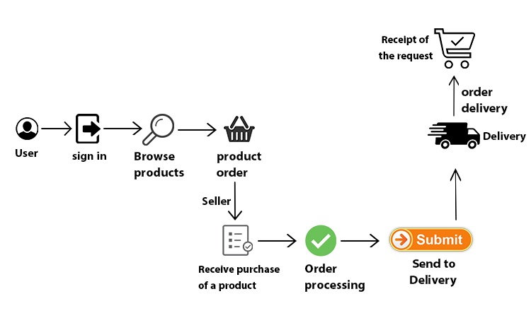At this point, we will talk about the system that will be used in the project and how it works.

**Figure 1.5: Application Diagram**

# We will design and program an electronic application in the form of an online store through which products are displayed. The application will consist of several pages, including the page related to logging in to the application or creating a new account for the user, seller and delivery, then we will move to the main page that represents the store interface so that it will display the product categories displayed in this store, which will be for example (food, drink, clothes, home antiques .... etc.) and when choosing one of these categories, you will be moved to the page for this category, which will display a number of items of the selected category and when choosing one of the items The item page will be moved and its data will be displayed such as (product image, price, description, etc.), and the quantity of the item is determined and added to the shopping cart. The request, when the request is prepared, the delivery service receives the request from the seller and delivers it to the user, and there is a page for the admin that consists of a page for displaying users and a page for displaying sellers and also for delivery to control the accounts of the application.

# **1.7 Project boundaries:**

At this point, we will talk about the limits on which the project stands:

1. Location.
2. Time.
3. Displaying products.

**1- Location:**

Currently, the project will be launched and made available in the Gaza Strip and does not currently include the West Bank, as it is difficult to communicate between them, but that will be preliminary. After launching the project and measuring the extent of its success in the Gaza Strip, a decision will be taken as the West Bank will be included in project or not.

**2- Time:**

the App will be open to receive orders around the clock, but in terms of delivery of the order, it depends on the readiness of the order, and if it is ready for delivery, the day on which the order will be delivered will be determined, and the delivery time will be from 10 am to 9 pm.

**3- Displaying products:**

At the present time, only the products of the productive families will be placed, because basically the project’s goal is to support the sale of their products, and at a later time, products made by commercial stores may be added.

# **1.8 Gant chart:**

At this point, we will present the project completion schedule:

**Table 1.1: Gant chart**

## **1.9 Summary:**

In this chapter, we explained an introduction to the project, dealt with the problem of the study and dealt with the solution from several aspects. We identified the objectives to be achieved, explained the project’s limits, mentioned the proposed system, and worked out a timetable for the completion of the project.

**Chapter 2**

**Background and**

**Literature Review**

# **2.1 Introduction:**

The proposed system was chosen to be in the form of a smart application running on mobile phones. In this chapter, we will explain the environment in which this system will operate, and we will also discuss studies of applications similar to ours and make a comparison between them.

# **2.2 What is a mobile phone?**

A smartphone is defined as a laptop computer built into the mobile phone. The smartphone is made with a display and smart technical software to manage personal information. The smartphone is also one of the devices that carry an operating system that allows running various computer programs, such as: web browsing, e-mail, Music, photos and many different applications.

# **2.3 What are mobile applications?**

It is a computer program that works on these mobile phones and tablets. Mobile phones are no longer just devices for voice telephone communications, but rather are used for exchanging multimedia messages such as pictures and videos, and using e-mail and the Internet.

# **2.4 What are programming languages?**

A set of commands or instructions that are written in a programming language, and the purpose of those instructions is to perform a specific task.

* + 1. **The most popular programming language:**

1- Java Script

2- PHP

3- C++ language

4- Python

5- Ruby

6- Flutter

* Flutter will be used for application programming and design, as well as application control panel design and programming and Firebase will be used as the application's database.

# **2.5 What is the language of Flutter?**

It is an SDK from Google dedicated to programming Android, IOS, and Fuchsia smartphone applications (a new operating system from Google), as it focuses on the user experience and the developer at the same time, because it provides a comprehensive framework in Dart language dedicated to drawing high-quality destinations and applications It is original with excellent performance and at the same time gives the developer the tools that make them build complete applications in the least amount of time.

# **2.6 What is the Firebase?**

Firebase is a platform launched by Google specialized in developing smart device applications. The platform includes a toolkit that covers a large part of the services that developers usually have to build themselves, but prefer to focus on the application experience itself. This includes: analytics, authentication, databases, file storage, etc.

Services are hosted in the cloud and can be expanded without any effort on the part of the developer. By cloud hosting, we mean that the products contain back-end services that are fully maintained and operated by Google. The SDK provided by Firebase interacts with these back-end services directly, without the need for any middleware between your application and the service.

So, if you're using one of the Firebase options, you'll usually write code to query your app's database.

# **3.2 Azeez App:**

It is an application located in the Gaza Strip similar to a store that provides all kinds of products of all kinds (food, drink, clothes, household appliances, home furniture .... etc.), in addition to that it provides public services such as (subscribing to TV programs, maintenance work ...etc) and includes the largest number of providers of these services in the Gaza Strip.

* + 1. **How the application works:**

You create an account, then log in, then choose a product and add it to the shopping cart, confirm it, then send you to wait for the order to be received, and the delivery will deliver it. In-app purchase.

* + 1. **Application disadvantages:**

The application has several drawbacks:

1- You can't pay with a card.

2- Does not use GPS.

3- The application is limited to the cities of the Gaza Strip and does not include the

cities of the West Bank.

**3.2.3 Application advantages:**

1- It includes all types of products with different categories and prices.

2- Get points as a coupon for every purchase from the application that is used

to purchase products from the application.

3- Covers all areas of the Gaza Strip.

4- Contains product discounts.

# **3.3 Sender App:**

It is an application similar to a store located in the Gaza Strip, which displays restaurants, bakeries and pharmacies located in the cities of the Gaza Strip, and through it you book an order and deliver to the customer.

* + 1. **How the application works:**

You create an account on the application and then go to the restaurant, pharmacy or store you want to buy the product from, then add it to the shopping cart and confirm the order and send you a message waiting for the order to be delivered and the order is sent through the delivery and payment is made in cash or through the card.

* + 1. **Application disadvantages:**

The application has several drawbacks:

1. Does not use GPS.

2- The application is limited to the cities of the Gaza Strip and does not

include the cities of the West Bank.

3- Limited to consumer products only.

* + 1. **Application advantages:**

1. Saving time and effort on the customer by delivering the product to him, regardless of his location.
2. Order and deliver the product at any time.

# **3.4 Jumia website:**

It is a website similar to a store that displays all kinds of sections of products in different price categories and the application is located in the State of Egypt and delivers products to the home or institution.

* + 1. **How the Website works:**

You create an account, then log in, then choose a product, add it to the shopping cart, confirm it, and then send you to wait for the order to be received, and the delivery will deliver it. Payment is in cash or through the card.

* + 1. **Website disadvantages:**

The only drawback in this application is that it provides its services in the state of Egypt only.

* + 1. **Website advantages:**

1- It provides all kinds of products in different sections.

2- There are always discounts.

3- Payment by card or cash as a convenience to the customer.

4- Free shipping on products if the value exceeds 350 pounds or more.

5- The possibility of requesting the return of purchases in the event of defects within 14 days.

6- Get products at very cheap prices, especially during occasions such as Black Friday and holidays.

## **2.7 Summary:**

In this chapter, we explained an introduction to the chapter and explained what the application would look like, and we explained everything related to the components of the proposed system, or we presented systems similar to ours and showed their pros and cons, and we compared them.

# **3.5 Comparing previous studies with the proposed system:**

**Table 3.1: Comparing proposed system**

|  |  |  |  |  |
| --- | --- | --- | --- | --- |
| **البيت الفلسطيني store** | **Jumia website** | **Sender**  **app** | **Azeez**  **app** | **Comparing** |
| **App** | **Website** | **App** | **App** | **system shape** |
| **Home and handmade products** | **All kinds of products** | **Products of restaurants, shops and pharmacies** | **All kinds of products** | **Products being marketed** |
| **Gaza script** | **Egypt** | **Gaza script** | **Gaza script** | **Geographical location** |
| **Cash** | **Cash or by card** | **Cash or by card** | **Cash** | **Payment method** |
| **No** | **Yes** | **No** | **Yes** | **Having discounts** |
| **Yes** | **Yes** | **Yes** | **Yes** | **Delivery** |

**Chapter 3**

**Methodology**

# **3.1 Introduction:**

# In this chapter, we will talk about the methodology chosen for the project, which is the agile methodology, and show the steps for implementing the project through it.

# **3.2 Project methodology:**

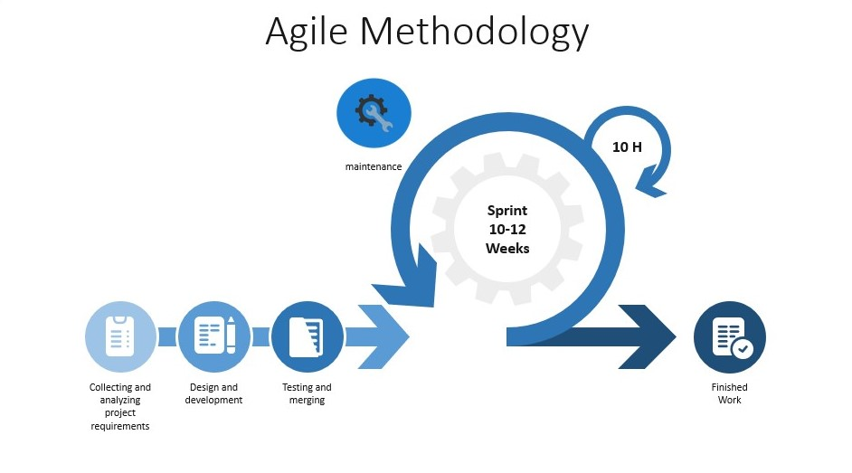

**Figure 3.1: Agile methodology**

We chose the agile methodology because of the speed and efficiency in getting the tasks done. Agile is a way to start managing software projects.

Here, the methodology shows that it will pass through 5 phases to complete the project, which are:

1- Collecting and analysing project requirements.

2- Design and development.

3- Test and merge.

4- Maintenance.

5- Project completion.

**1- Collecting and analysing project requirements:**

At this stage, we analyzed the project to know its requirements, so that we identified the proposed system for the project, and then we determined what the application would look like, and we determined the programming language used in developing the application. For the application, which are the productive families, which are considered as a selling point for the products, and there is a delivery service to deliver orders and the user who made the purchase.

**2- Design and development:**

After we study and analyze the project requirements, at this stage we will design and develop the proposed system that has been identified, which is an application for mobile phones in the form of a store, the Flutter programming language was used to develop the application.

**3- Test and merge:**

At this stage and after the development and creation of the application, a test of the application will be made to test the efficiency of its work and to know if it contains problems so that if any, they are dealt with and maintained.

**4- Maintenance:**

At this stage and after the process of testing the application and verifying its performance at work, if software problems are detected, they are verified and repaired, and the application is prepared for release to users.

**5- Project completion:**

After completing all the previous stages, the application is ready to be launched and used by users.

## **Summary:**

In this chapter, we talked about the agile methodology and how it was used in the implementation stages of the application.

**Chapter 4**

**The Proposed System**

## **4.1 Introduction:**

## In this chapter, we will explain the proposed system and its models, and we will analyze the system, and we will also address the design of the system, presenting its contents, and finally testing the system.**.**

## **4.2 Models:**

The application system consists of several models, each model has its own work. The system is divided into 5 models:

1- The user.

2- The owner of the product or the seller.

1. The delivery operator.
2. Dashboard in the application.
3. Firebase.



**Figure 4.2.1: System Design**

* **The user:**

In this form, users look at the available stores or sellers, look at their products, order a product and confirm it, and the user's data (location, number, address, etc.) is taken, and then he waits for his order to arrive.

.

* **The owner of the product or the seller:**

Here, sellers create their own stores on the application so that they sell their own products through it and also receive orders from users and prepare orders for them.

* **The delivery operator:**

In this form, the delivery worker receives requests sent by users and waits for the order to be ready. When the order is ready by the seller, he delivers the order to the user according to the data received by him.

* **Dashboard in the application:**

It is a panel that controls the accounts of users, vendors and delivery workers so that it controls these accounts by activating or disabling them.

* **Firebase:**

It is a database that includes all data related to the application and its control (accounts of users, sellers, delivery workers, products and their items...etc.).

## **4.3 System Analysis:**

Here we will analyze the proposed system and its mechanism of action and display diagrams for each part of the system and analyze it.

* + 1. **Case Diagram:**

The following diagrams show the status and functions of each partition in the system:

1. **User:**

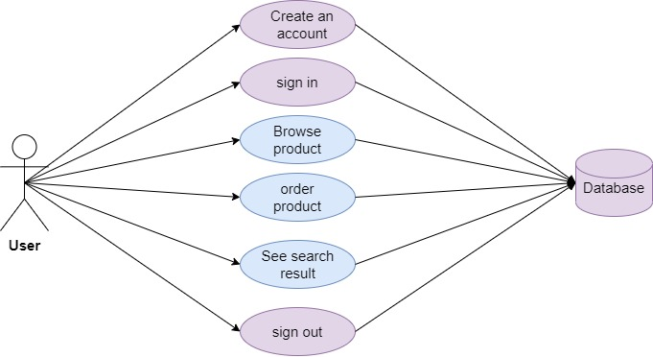

**Figure 4.3.1.1: user diagram**

In this diagram, it shows the status of the user in the system, and as shown, he logs in through his account to the application after its creation, browses the available products, orders products, sees the search results he performs, and finally logs out of the application and all this is based on the database of the application.

1. **Seller:**

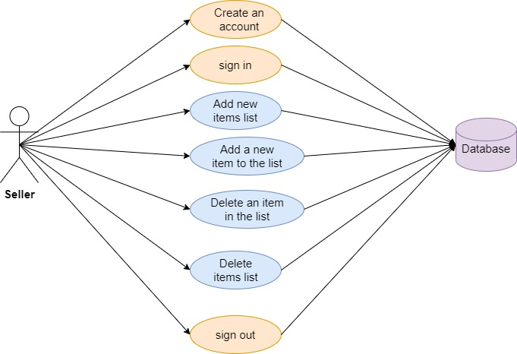

**Figure 4.3.1.2: seller diagram**

In this diagram, it shows the status and functions of the seller in the application. The seller logs into the application after creating his own account, and then creates a list of the items he wants to sell, and then leads by entering the items inside, and he can delete any item in the list or delete the entire list and also see the requests received by him and in the end it logs out and all this is based on the application database.

1. **Delivery:**

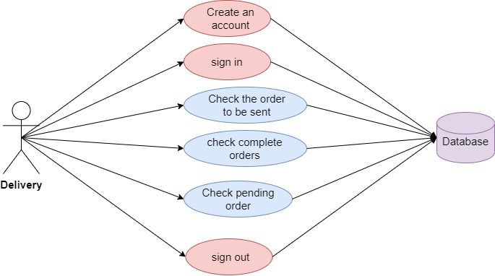

**Figure 4.3.1.3: Delivery Diagram.**

Here we show the status and functions of the delivery employee so that he logs into the application after creating his own account and after that he checks the requests received by him and also he can check the orders that have been delivered and the orders that he put on the waiting box and in the end he logs out and all this is based on the rule Application data.

1. **Admin:**

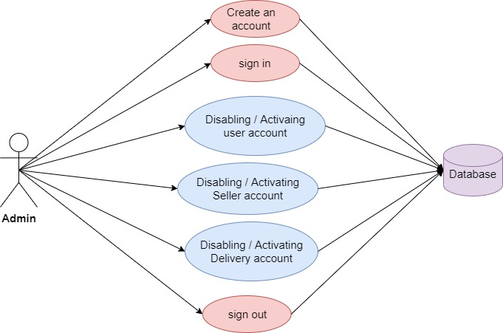

**Figure 4.3.1.4: Admin diagram**

This diagram shows the status and functions of the administrator on the application. He logs into the control panel after creating his own account. Then he has the ability to control the accounts used on the application by (users, sellers, and delivery workers) so that he disables or activates those accounts when needed and All of this is based on the database.

* + 1. **Interactive Diagram:**

It is a business plan and a document that summarizes in a scientific way the strategy that the organization or users of the application will follow to reach the goal within a certain period of time:

1. 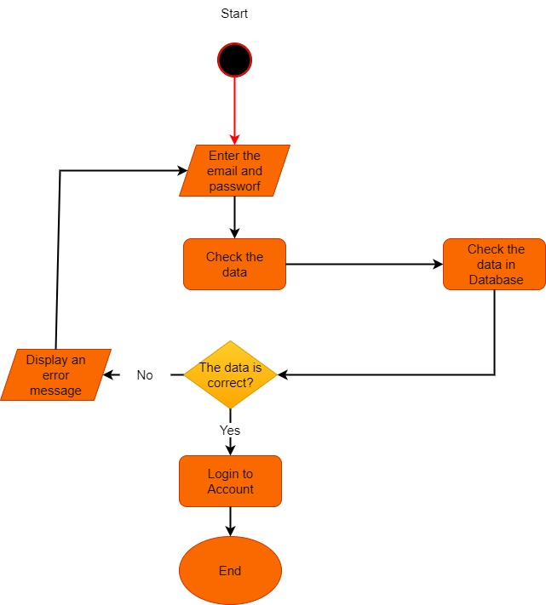**User:**

**Figure 4.3.2.1: User Login diagram**

In this diagram, it displays the login process for the user, he logs into the application by entering the e-mail and password, then the application verifies the data entered and checked in the database, and when the verification is completed, if it is correct, the application is logged in, and if it is not an error message appears and the application returns him to the login page again.

1. 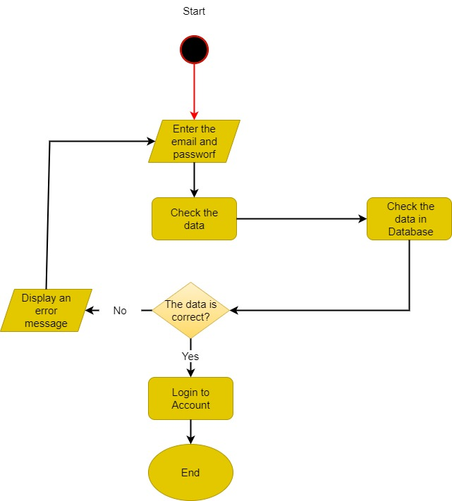**Seller:**

**Figure 4.3.2.2: Seller Login diagram**

In this diagram, it displays the process of logging in the seller, he logs into the application by entering the e-mail and password, then the application verifies the data entered and checked in the database, and when the verification is completed, if it is correct, the application is logged in, and if it is not an error message appears and the application returns him to the login page again.

1. 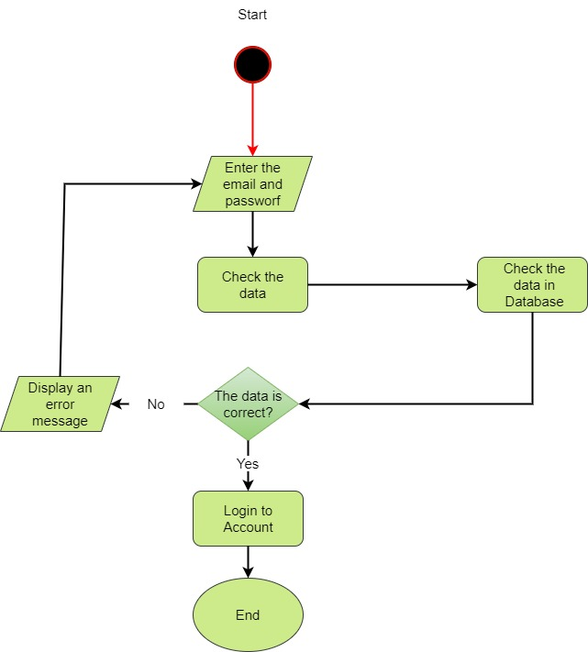**Delivery:**

**Figure 4.3.2.3: Delivery Login diagram**

In this diagram, the login process displays the delivery worker, who logs into the application by entering the e-mail and password, then the application verifies the data entered and examined in the database, and upon completion of verification, if it is correct, the application is logged in to the application, and if it is not an error message appears and the application returns him to the login page again.

1. **Admin**:

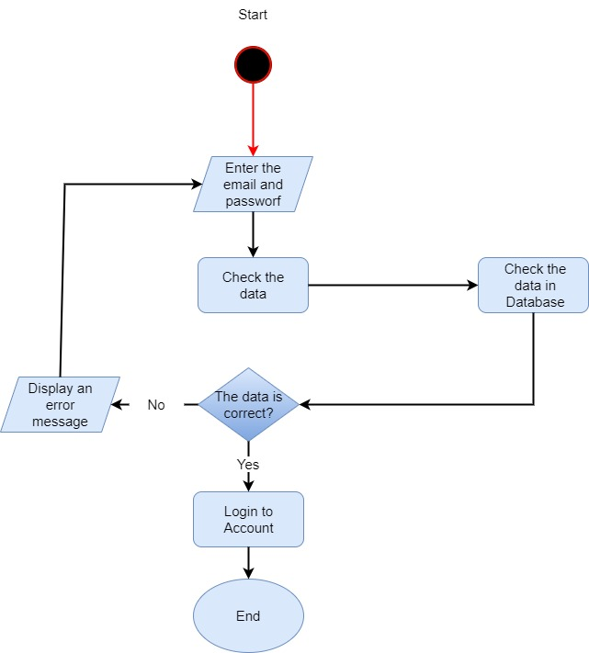

**Figure 4.3.2.4: Admin Login diagram**

In this diagram, the administrator login process, he logs into the application by entering the e-mail and password, then the application verifies the entered data and checks it in the database, and upon completion of verification, if it is correct, the application is logged in to me, and if it is not, it appears to him an error message, and the application returns it to the login page again.

* + 1. **Chart Diagram:**

1. 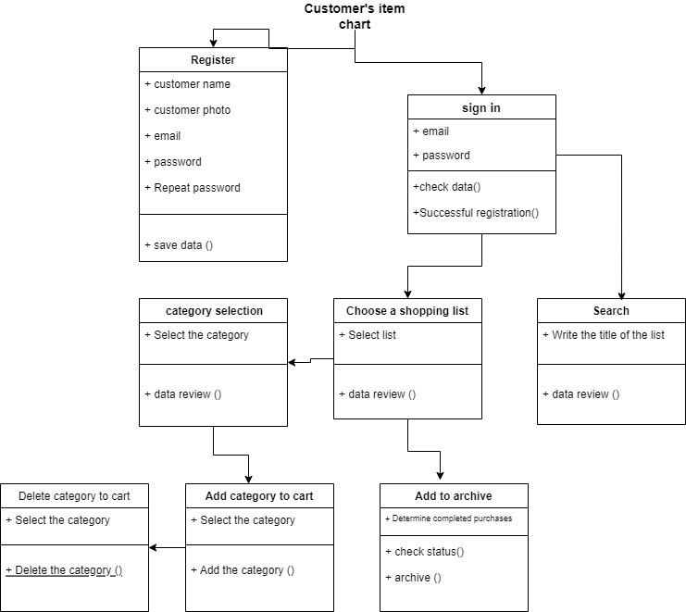**User Chart**

**Figure 4.3.3.1: User Chart diagram**

In this diagram, we show the mechanism of the user's account so that he first logs in and adds the following data (user name, photo, email, password and repeat password) This data is saved in the database and then goes to the login page and enters the email The password is checked, validated and saved, and then the application is entered, the user browses and searches the available stores and chooses one of them, and the contents of those stores are displayed, then he chooses one of those displayed contents and then it is added to the shopping cart and if the user wants to delete it He chooses the selected product and then deletes it from the basket. If the product is requested, it is verified and archived.

1. 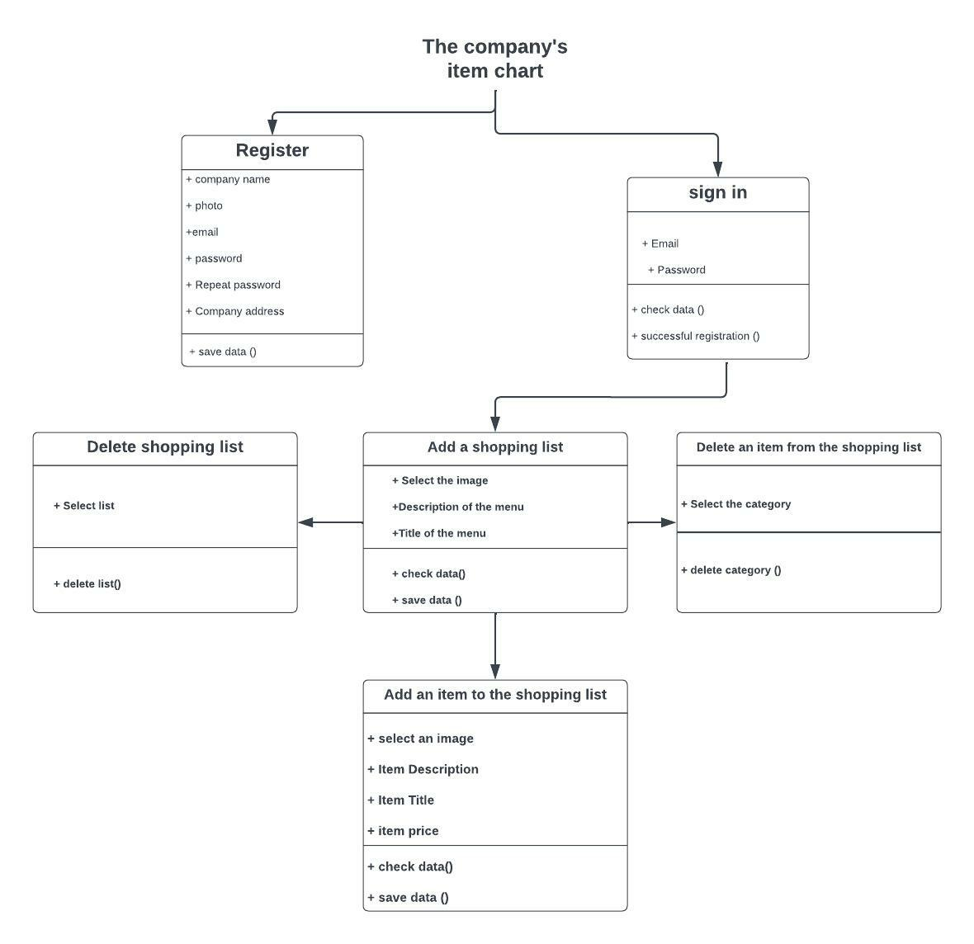**Seller Chart:**

**Figure 4.3.3.2: Seller chart diagram**

In this diagram, it shows the mechanism of the seller's account. At first, the seller creates an account on the application and enters the following data (store name, store account picture, email, password, retype password, store address) the data is saved in the database and then Go to the login page, he logs into the application by typing the e-mail and the password. The entered data is verified and saved. Then, entering the application, the seller makes a custom list with certain items so that he selects a picture of the list and writes a description of the list and a title for it, that data is saved and checked Upon request, he then adds items within that list so that he identifies a picture of it and writes a description of the list, address and price for it. Those data are saved and checked upon request. If the seller wants to delete an item, he selects it from within the list and deletes it, and he can also delete the entire list.

1. **Delivery:**

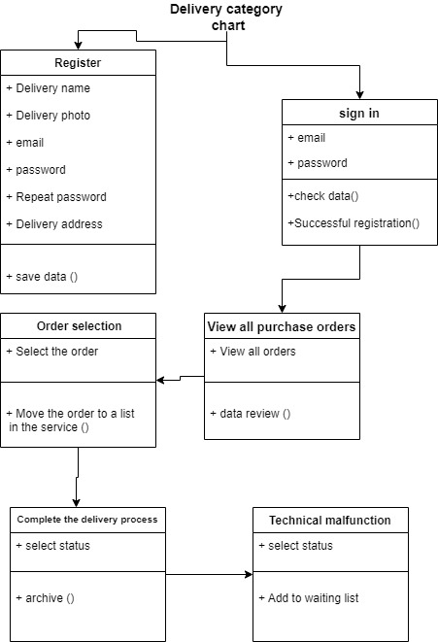

**Figure 4.3.3.3: Delivery chart diagram**

In this diagram, it shows the mechanism of the delivery account. At first, the delivery creates an account on the application and enters the following data (his name, photo, email, password, retype password, delivery address) the data is saved in the database and then go to the page Login, he logs in to the application by typing the email and the password. The entered data is verified and saved, then enters the application. The delivery displays the requests to be connected and then selects the request to be connected to be transferred to the delivery service and then transferred. The process completion box that displays the delivery status of those the order, and in the event that it is not possible to deliver the order at the present time, it will be transferred to the waiting box.

1. **Admin:**

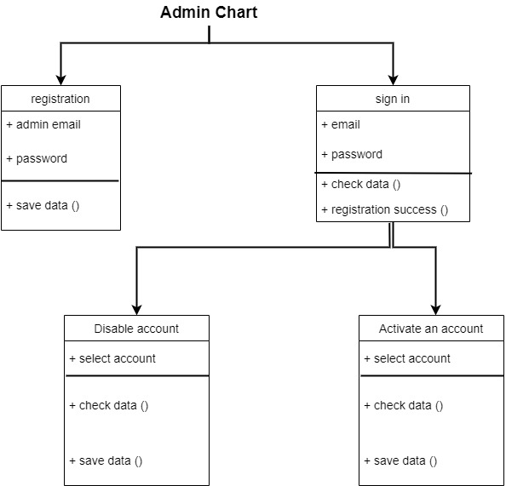

**Figure 4.3.3.4: Admin Chart diagram**

In this diagram, it shows the mechanism of the administrator account. At first, the administrator creates an account on the application through the database and enters the following data (email, password) the data is saved in the database and then go to the login page, he logs in to the control panel By typing the e-mail and password, the entered data is verified and saved, and then entering the control panel, the administrator displays the accounts on the application for each of (user, seller, delivery) and disables and activates those accounts according to certain terms and conditions.

## **4.4 System testing**

## In this part, we will show the application test and the effectiveness and efficiency of the application:

1. Test the creation of a new account for each of the user, seller and delivery.
2. Test the login process for the user, seller and delivery.
3. Test the process of logging into the application in the right and wrong way.
4. Test the side menu and its functions.
5. Test adding a new list of products.
6. Test adding new products to the list.
7. Test the process of locating the place through Google Maps.

8- Test the appearance of the order data.

9- Test whether the order has been delivered or not.

10- Test the use of the delivery of Google Maps.

11- Application miss test to fill in a very important field.

12- Testing the appearance of the deletion message when deleting an order, list or product.

13- Testing the logout process for the user, seller and delivery.

## **4.5 System results**

At this point, we will present the design of the application interfaces for each part of it, as well as the control panel and explain the work of each interface.

After trying the application, these are the results that were reached:

1- Providing services to customers by choosing one of the owners of the products in the application and ordering their products easily without any complexity.

2- Giving the seller the ability to sell any type of product and its own items on the application.

3- Providing delivery services to customers through the delivery workers on the application.

4- Helping delivery workers to locate vendors and customers in order to receive and deliver orders.

5- Helping sellers to deliver their products to the largest number of customers through the application, and thus an increase in material income.

* + 1. **Main interface:**

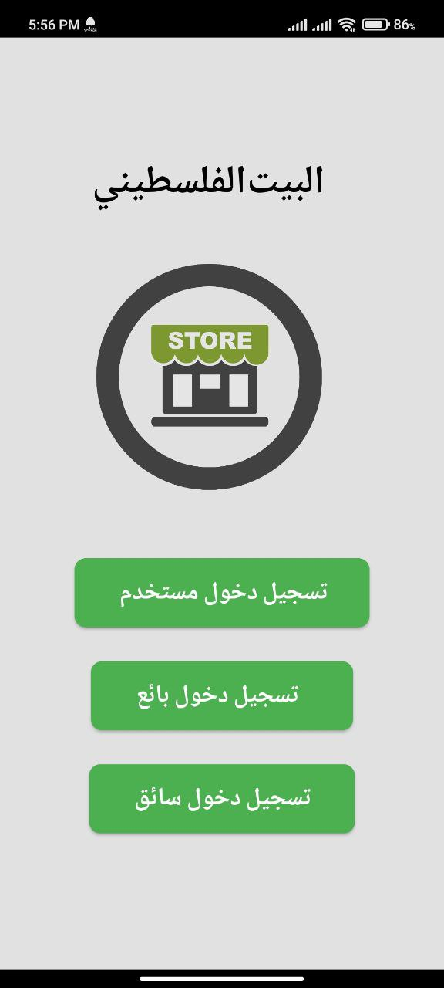

**Figure 4.5.1.1: Main interface**

This screen represents the beginning of the application as it contains three buttons, each button brings you its own interface.

* + 1. **User results:**

We will explain how each of the user interfaces work.

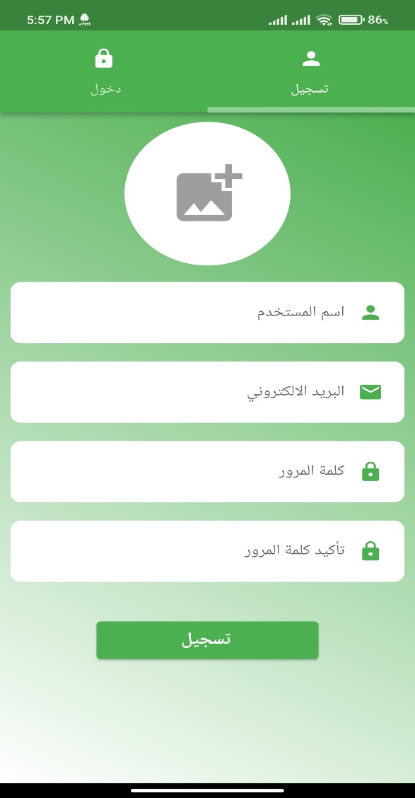

**Figure 4.5.2.1: User Cerate account**

In this interface, the user creates an account on the application and is asked to write:

1- Username

2- email

3- Password

4- Repeat password

And press register and then go to the login interface

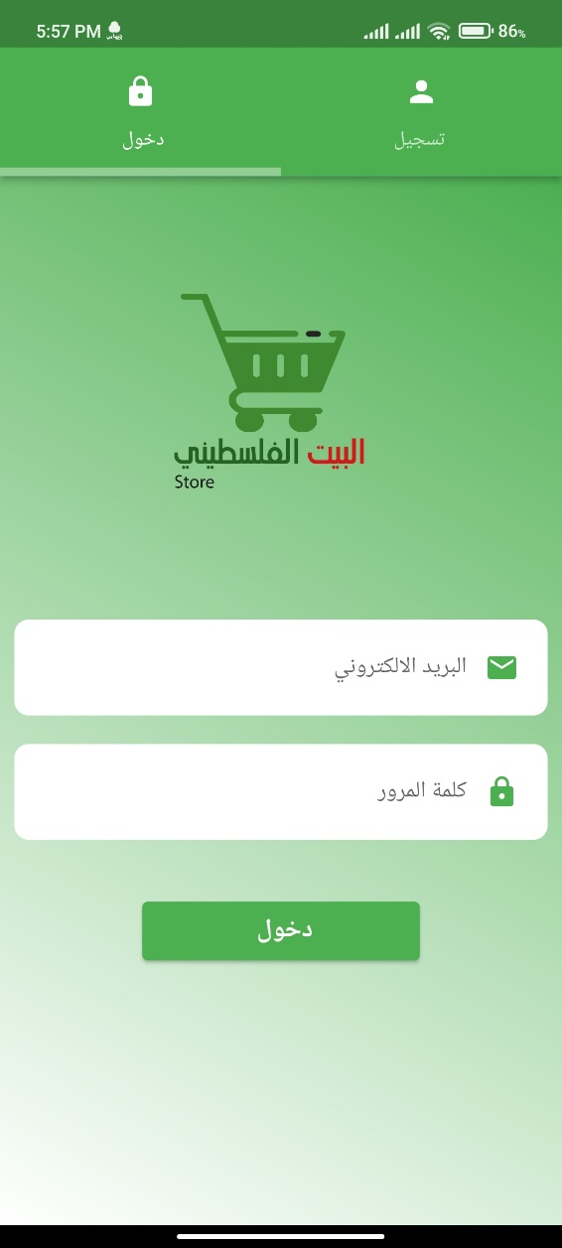

**Figure 4.5.2.2: User sign in**

In this interface, after the user creates his own account, he comes here and enters the email and password in order to log into the application.

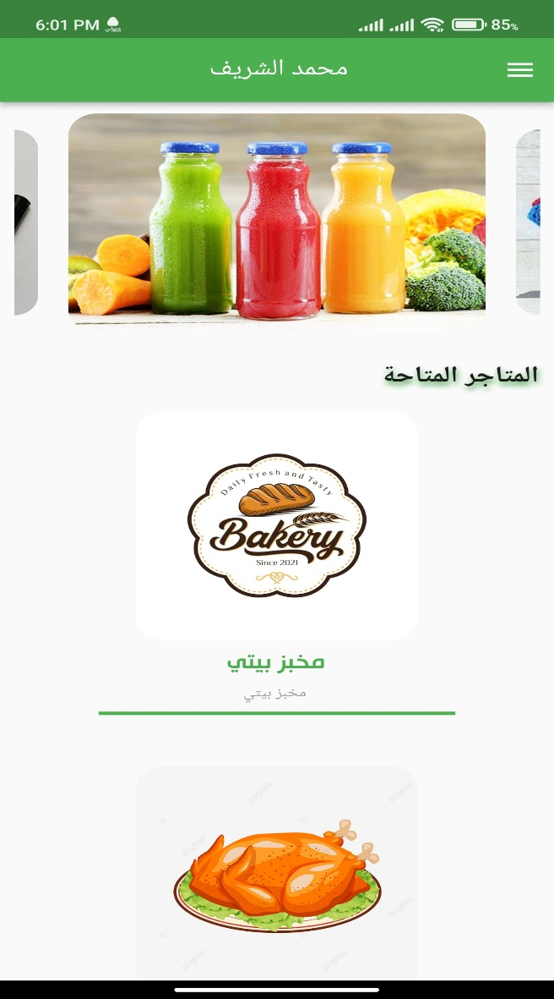

**Figure 4.5.2.3: User main interface**

This interface is the main interface in the user application, as it displays the vendors available in the application and also provides pictures of some of the goods sold in the application so that the user gets an idea of the items that are sold in the application.

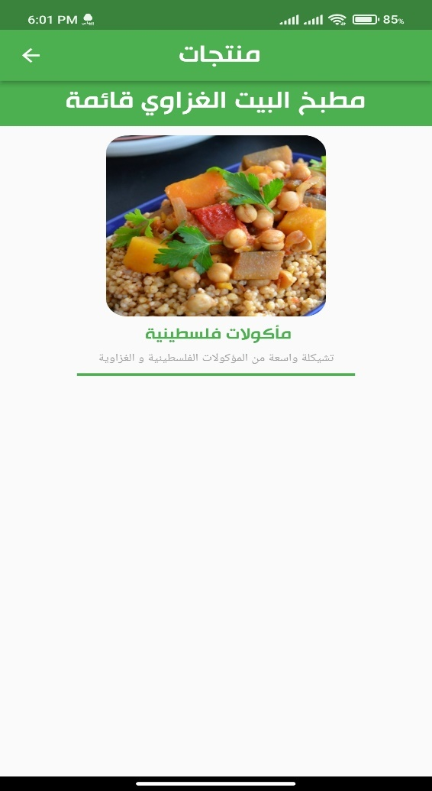

**Figure 4.5.2.4: User select Seller**

After the user chooses one of the sellers, for example (the Gazan house kitchen), he browses the lists of items for this seller and chooses one of them.

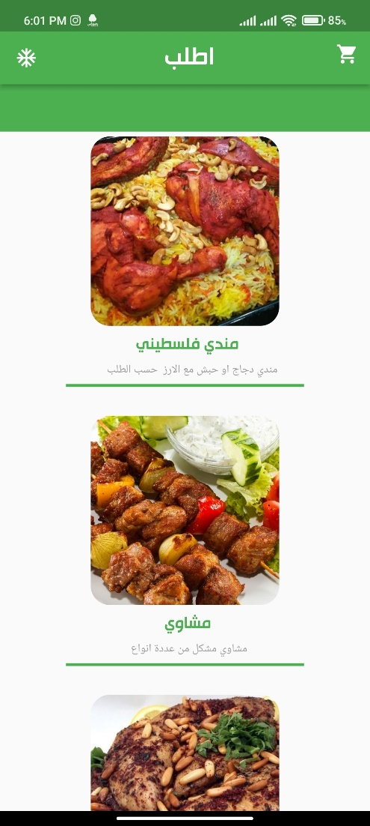

**Figure 4.5.2.5: user select product**

After the user chooses one of the lists, he browses the products inside and chooses one of them to purchase.

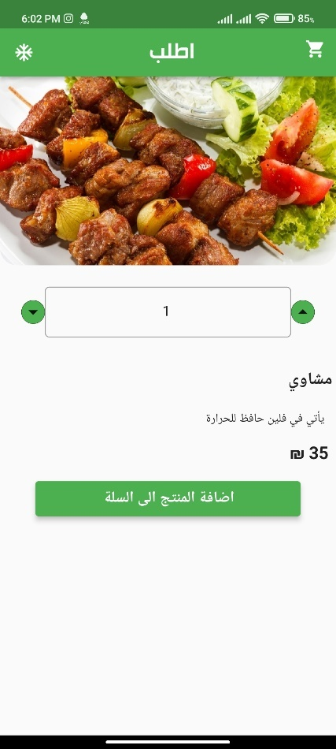

**Figure 4.5.2.6: Add to Cart**

Here he determines the quantity of the selected product and will show him the total price and add the product to the Cart.

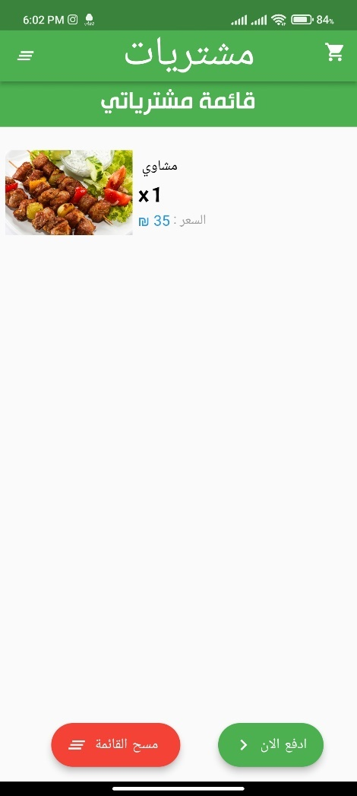

**Figure 4.5.2.7: Ordered the Product**

After sending the order to the shopping cart, we click on the basket icon on the top right of the screen to go to the basket. Here, the selected product, its price and the required quantity are displayed. Here the user confirms his order by clicking Pay Now, the product moves to the list of orders and the seller receives the product.

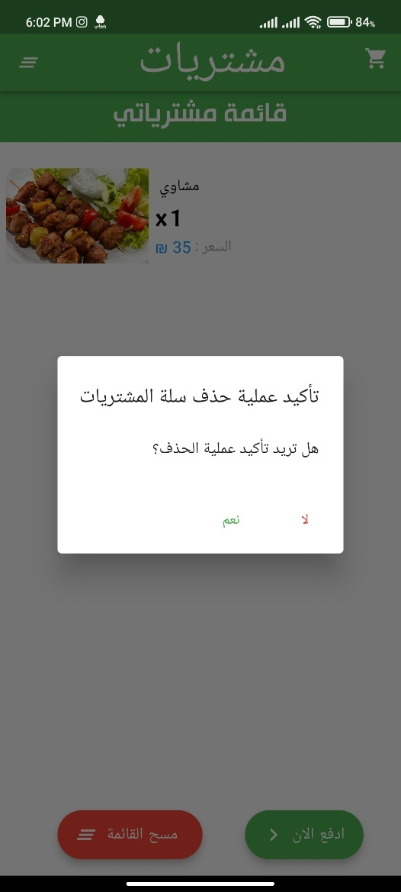

**Figure 4.5.2.8: Delete the Order**

In the event that the user wants to delete the order, he presses on Clear List, a confirmation message appears on the deletion process, and after confirmation, the product is deleted from the shopping cart.

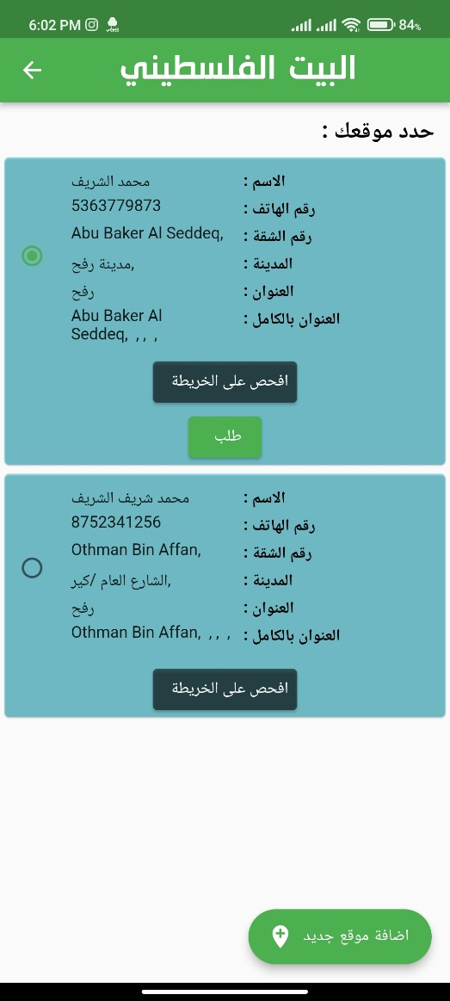

**Figure 4.5.2.9: select user location**

After confirming the request, we move to the user’s location interface. The user selects his location. The interface saves this location in case the user wants to use it again. When the location is selected, the option to check appears on the map and the request option to send it to the delivery.

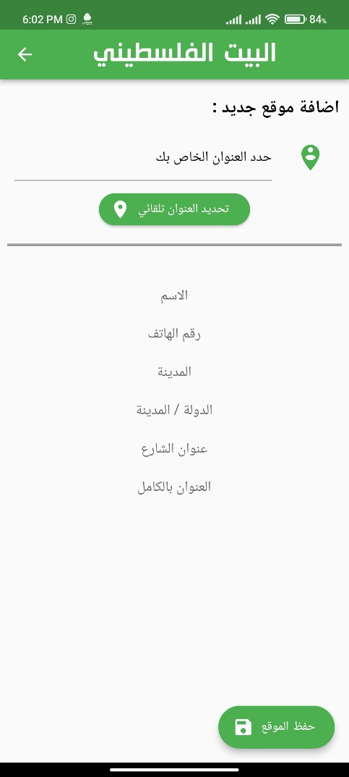

**Figure 4.5.2.10: Select new Location**

In the event that the user wants to select a new location, in the previous interface, he presses the button to add a new location. In this interface, you select the location automatically when you press the button on the interface. Additional information is also written to be placed on the order invoice, name, number and city .... etc. of the required data.

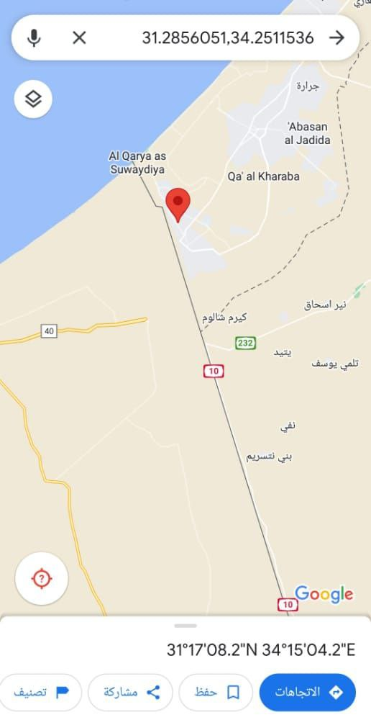

**Figure 4.5.2.11: Location in Map**

This interface shows the location that the user has chosen via Google Maps. It shows the location that the delivery is supposed to reach.

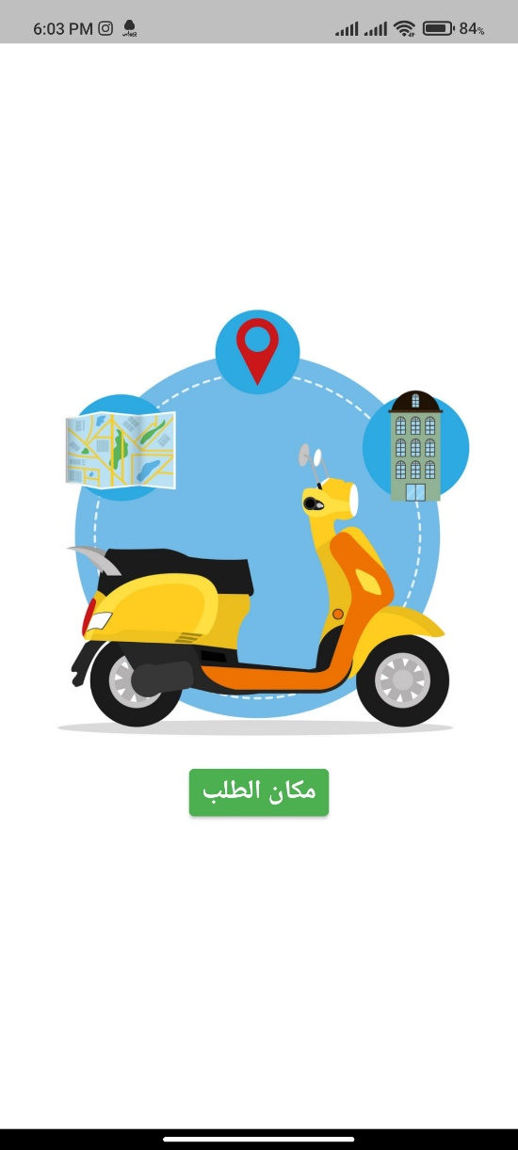

**Figure 4.5.2.12: confirmed the Order**

In the locator interface, after selecting the location for the user, he presses the Request button to show this interface to him until the request is confirmed and sent to the seller and delivery.

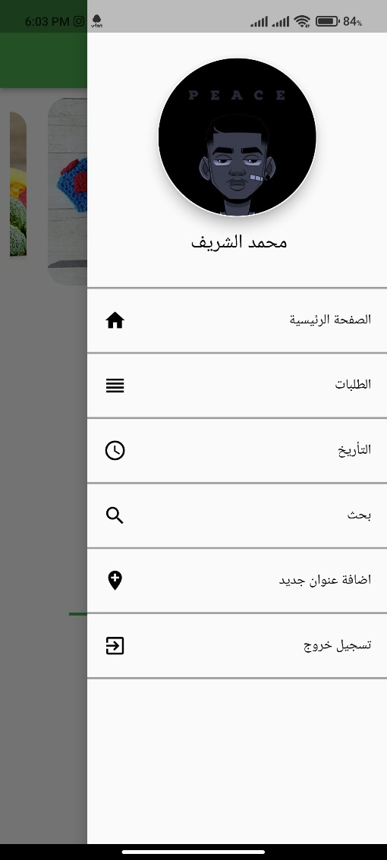

**Figure 4.5.2.13: user menu**

This interface represents the user's account menu and contains a number of things such as: requests, archiving, searching, adding an address, logging out.

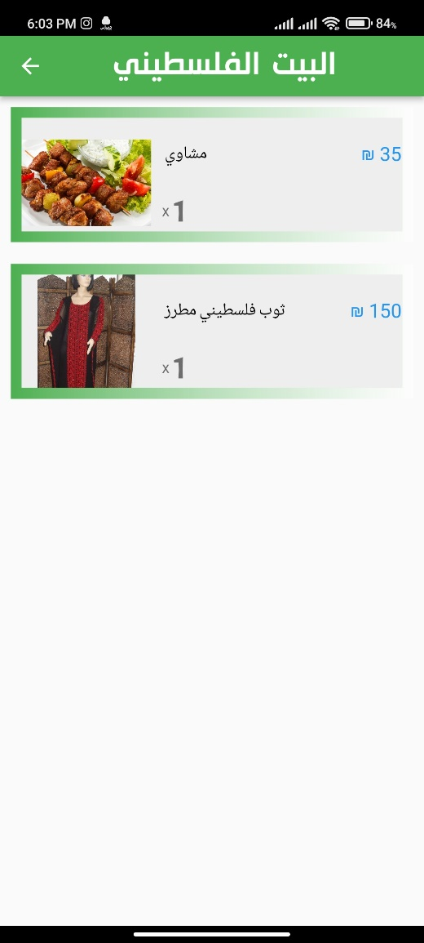

**Figure 4.5.2.14: Orders**

When you click on the requests option in the user list, you will see requests that have not yet been received.

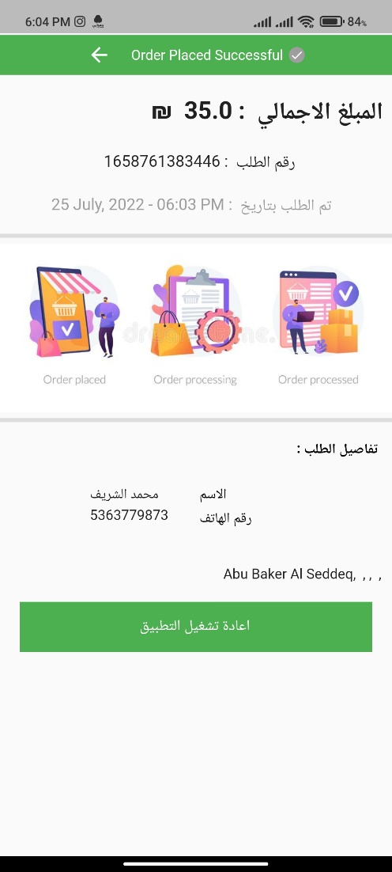

**Figure 4.5.2.13: Order Information**

When you click on one of the orders in the Unreceived Orders option, information about the order price, number and user data appears.

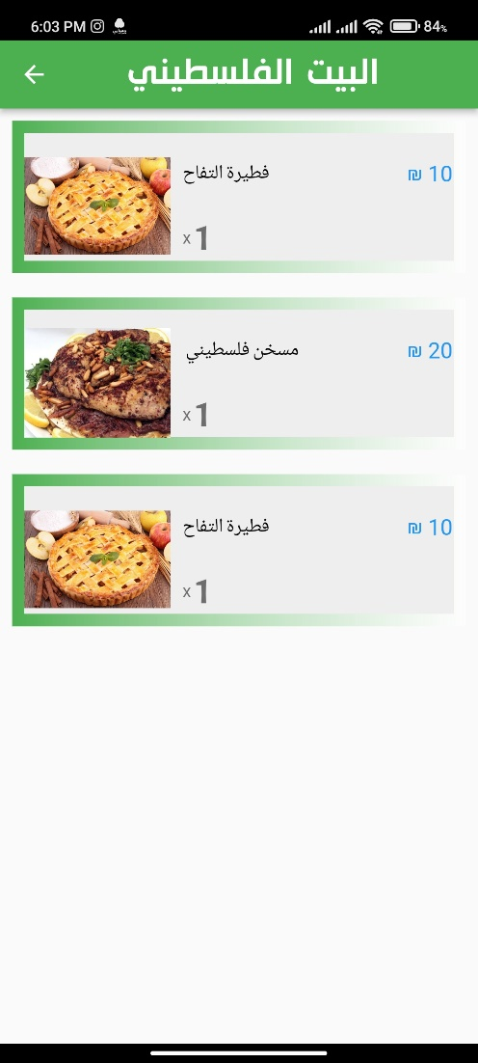

**Figure 4.5.2.14: Archive Order**

When you click on the archive button, the requests that have been delivered to the user are shown.

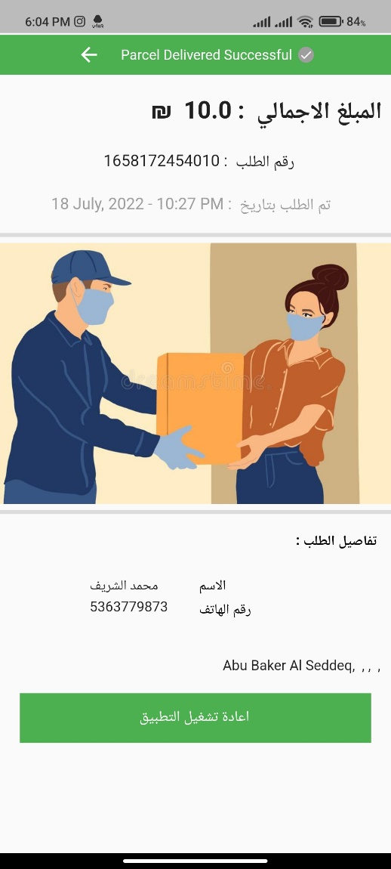

**Figure 4.5.2.15: Order Information**

When you click on one of the orders in the archive, the following interface appears, which carries the data of the received order, such as its price and number, and also carries the user data.

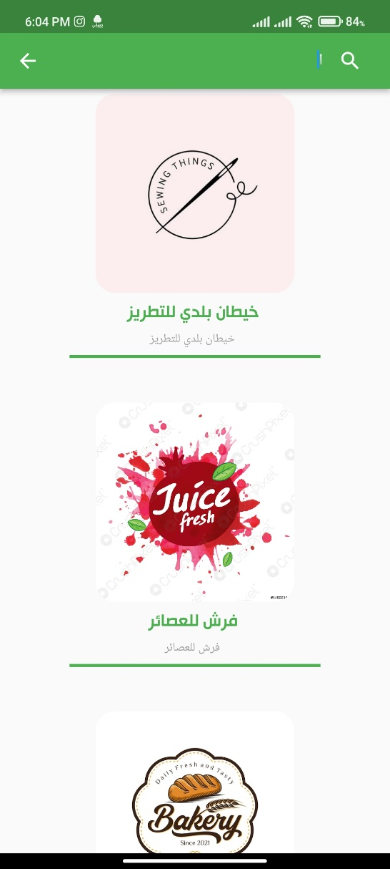

**Figure 4.5.2.16: Search Seller**

When you click on the search option, a search interface appears so that the user searches for a specific seller in order to reach his products.

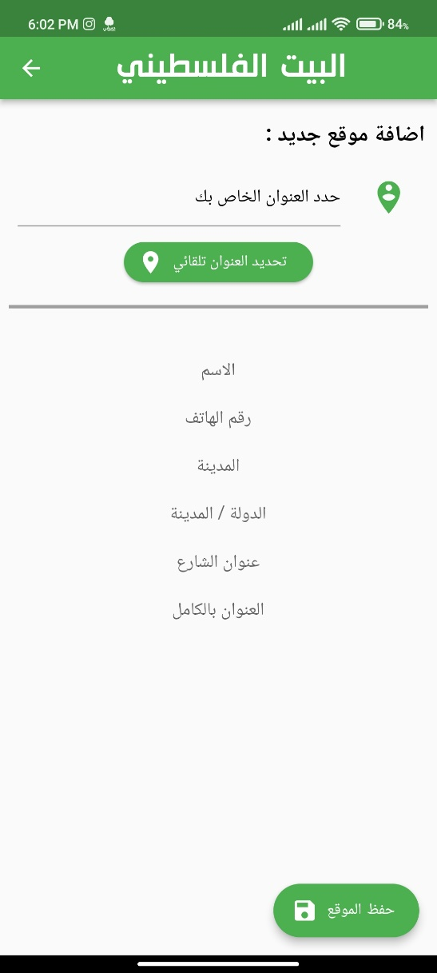

**Figure 4.5.2.17: Select new Location**

When you click on the option to add a new site, you will go to the site selection interface in order to add it to the user's sites.

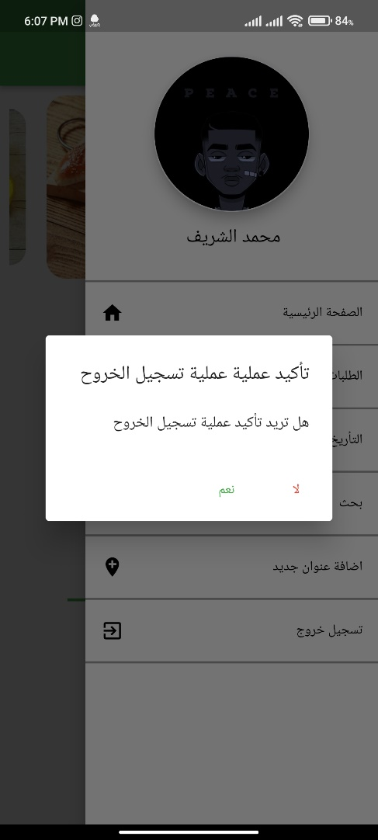

**Figure 4.5.2.18: Sign Out**

Finally, when the user wants to exit the application, he presses the “Logout” option, a confirmation message appears to log out, and upon confirmation, the user is logged out.

**4.5.3 Seller results:**

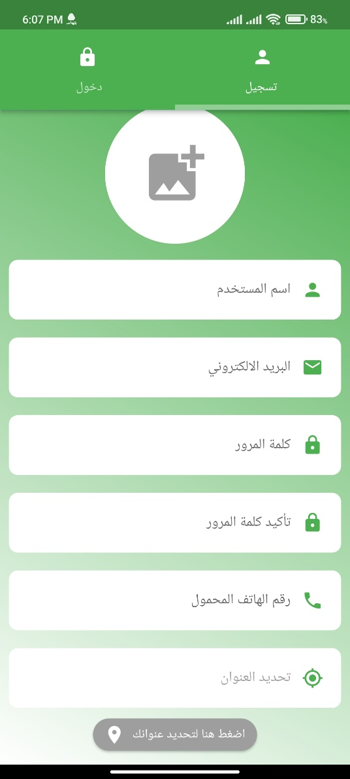

**Figure 4.5.3.1: seller Registration**

In this interface, the seller creates his own account by typing his project name, e-mail and password, confirming it, adding the phone number, and also locating his location automatically when pressing the address selection button.

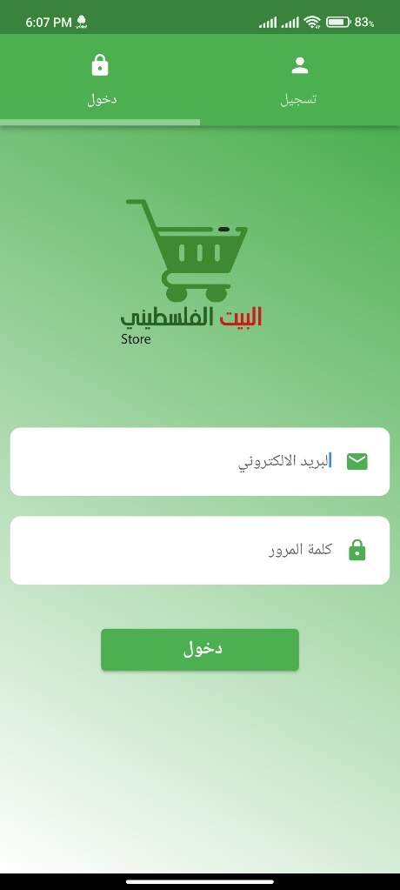

**Figure 4.5.3.2: seller sign on**

After the seller creates his account, he moves to the login interface in order to enter the application.

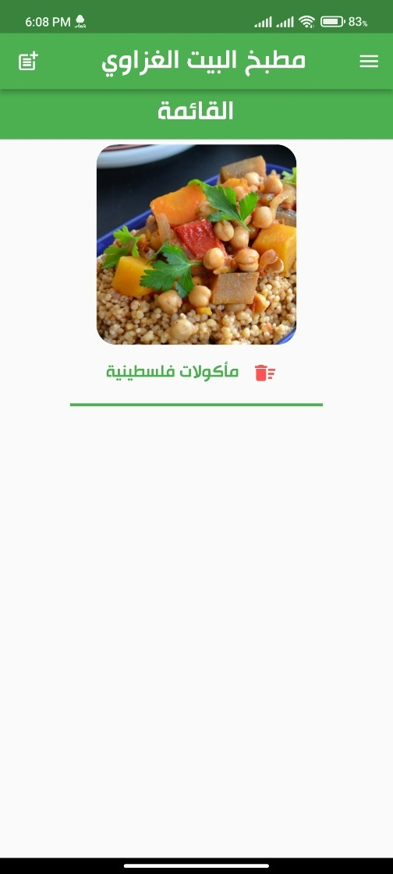

**Figure 4.5.3.3: seller Main interface**

After logging in to the application, the main page of the seller's interface is displayed, which displays lists of the items that he sells, and in order to create a new list, we click on the icon at the top left of the screen.

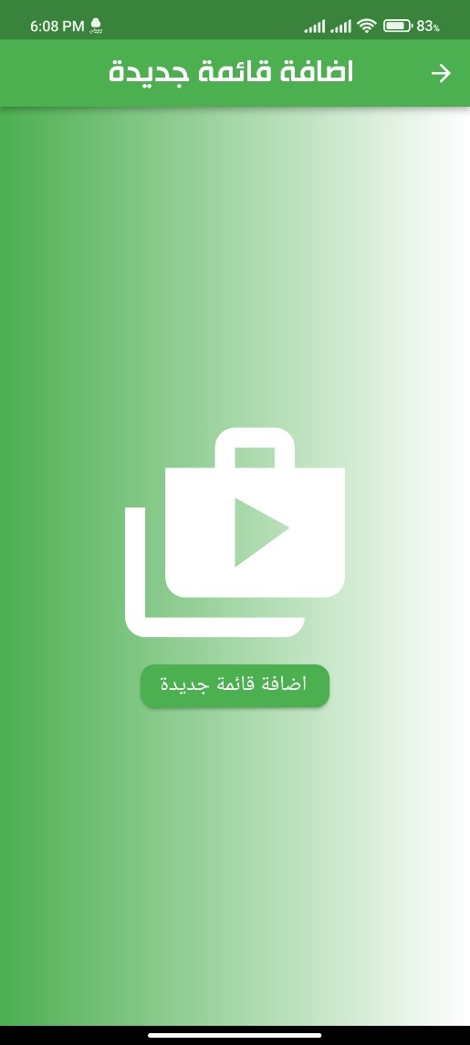

**Figure 4.5.3.4: Add new category**

After clicking on the icon, we will move to the current interface, where you will create a list of products.

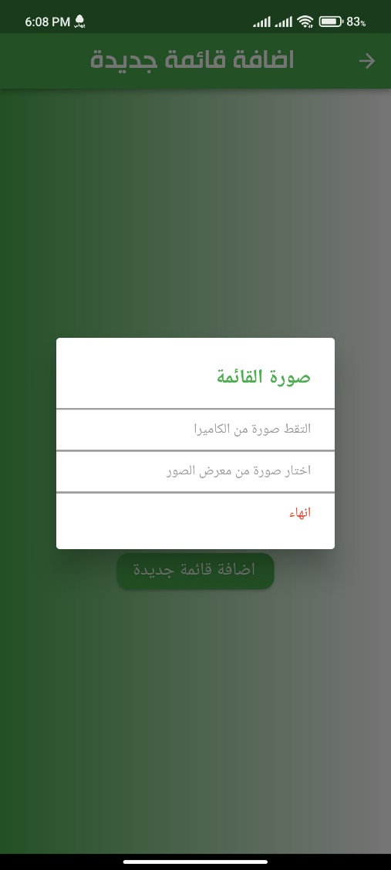

**Figure 4.5.3.5: Add new category**

When you click on Add a new list, the following message appears in order to choose an image for the list.

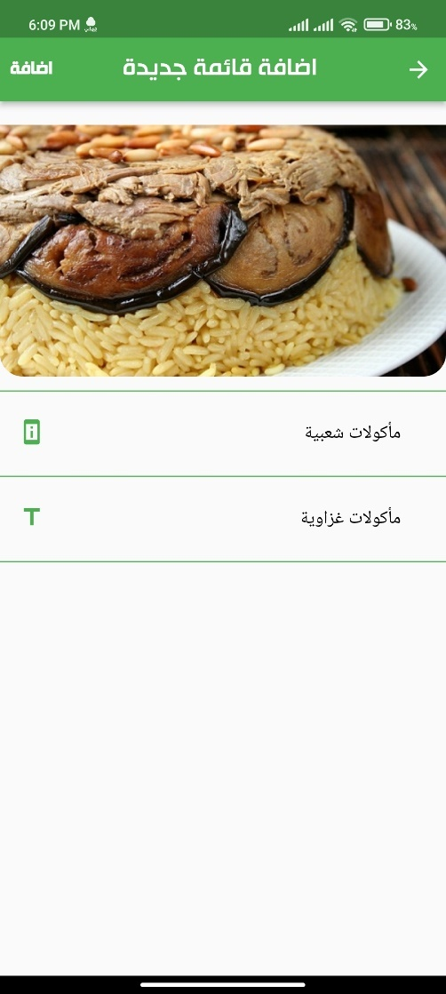

**Figure 4.5.3.6: add information for category**

After selecting the image, it is moved to the current interface to write a description and title for that list.



**Figure 4.5.3.7: Add an item**

After all that, we go to the next interface that contains the items within the list, to add a new item we click on the icon at the top left of the screen

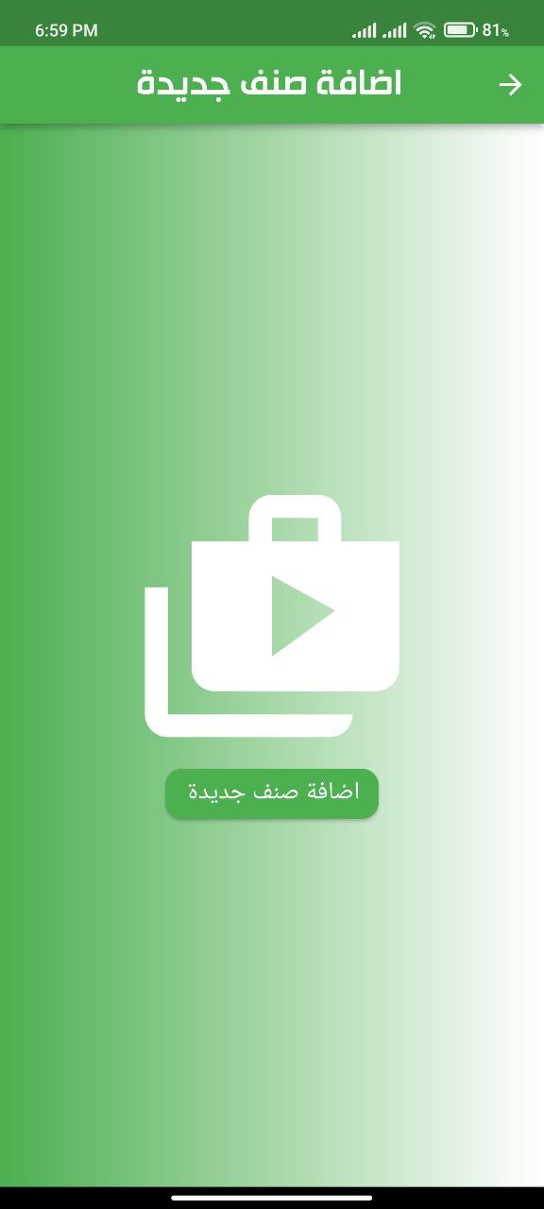

**Figure 4.5.3.8: Add new items**

In order to add a new category, we click on Add a new category.

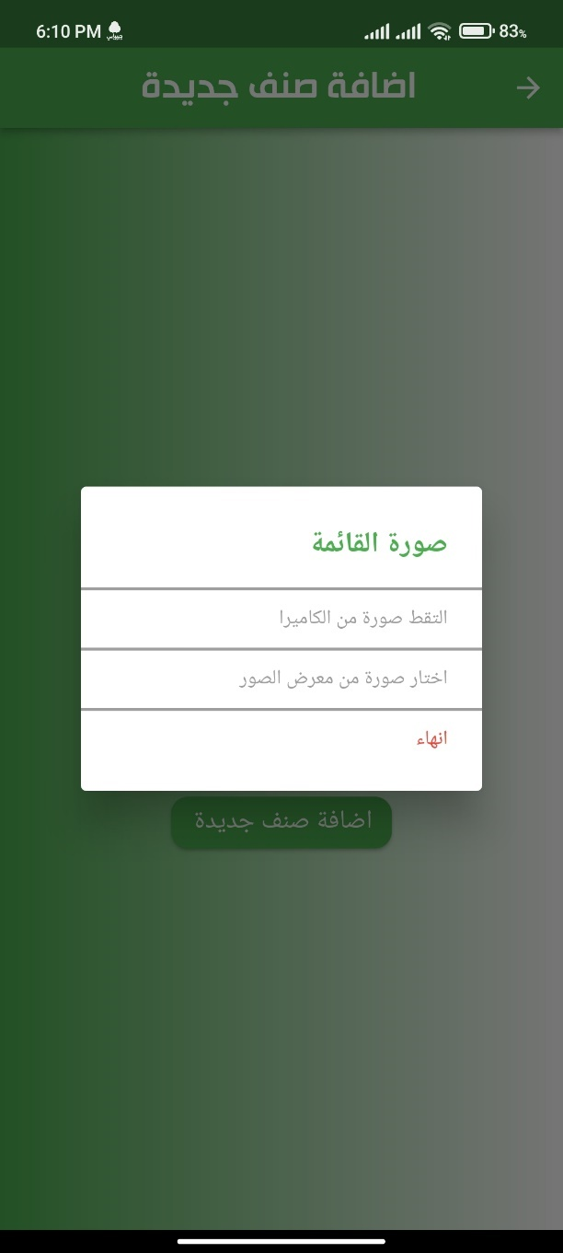

**Figure 4.5.3.9: Add new items**

When you click on Add a new item, the following message appears in order to choose an image for an item.

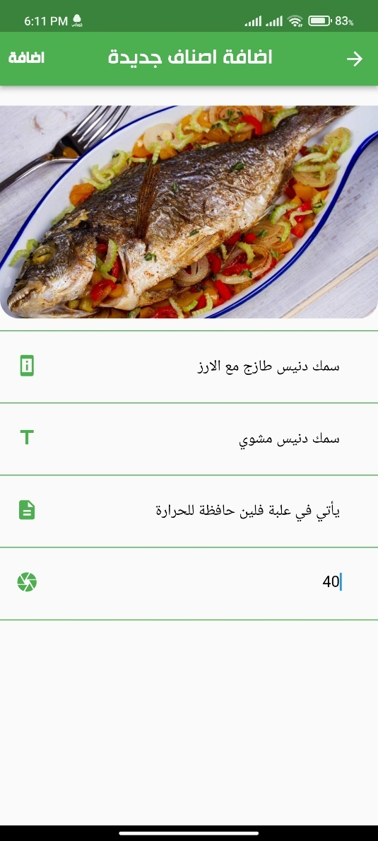

**Figure 4.5.3.10: Add item information**

In the next interface, we add data related to the item such as its description, address, note and price.

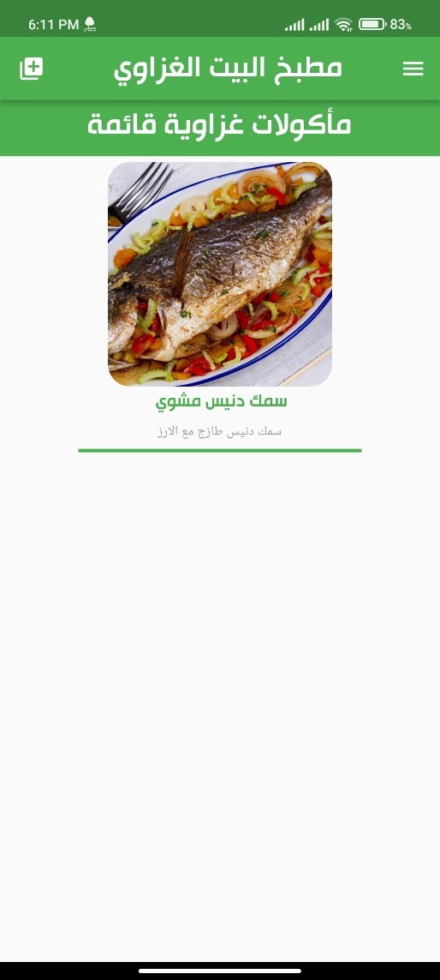

**Figure 4.5.3.11: items**

Thus, an item has been added to the list.

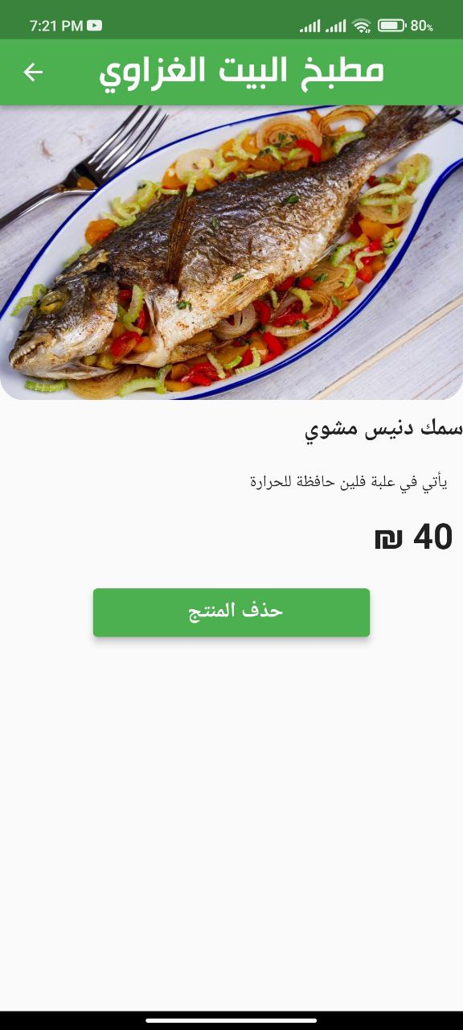

**Figure 4.5.3.12: Items information**

When you click on the item's image, it goes to an interface that displays the item's image and data, and this item can also be deleted from the list.

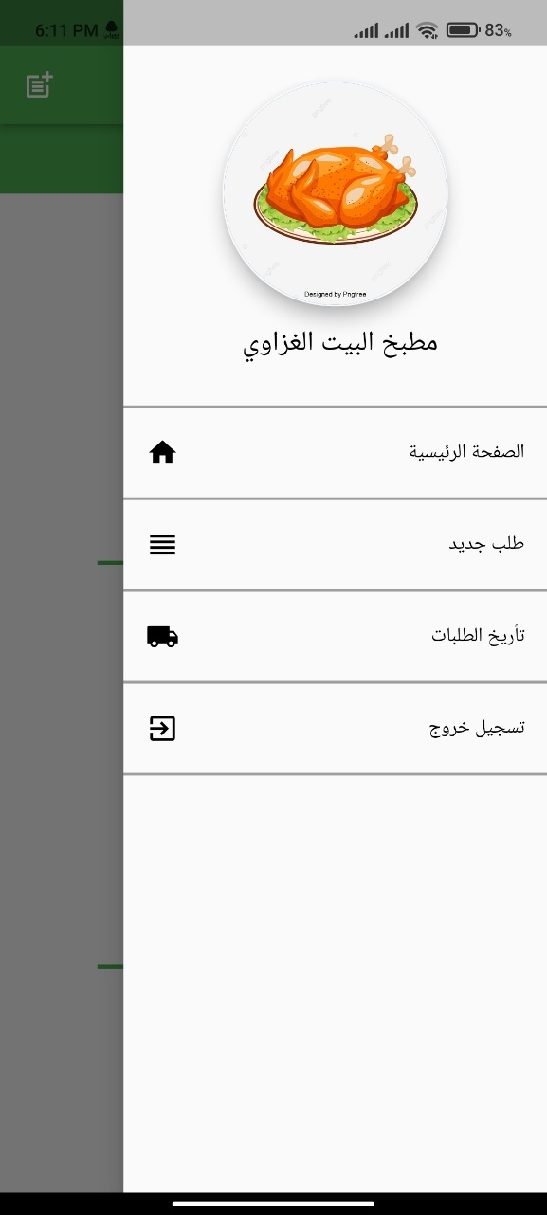

**Figure 4.5.3.13: Seller menu**

The following interface displays the menu for the seller's account and contains options: new order, archive orders and checkout.

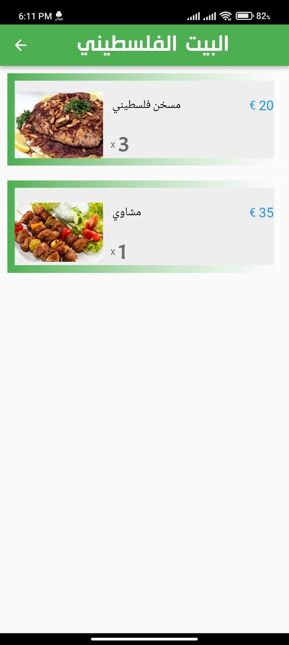

**Figure 4.5.3.14: New order**

When you click on the new request option, the following interface appears displaying the new requests requested by users.

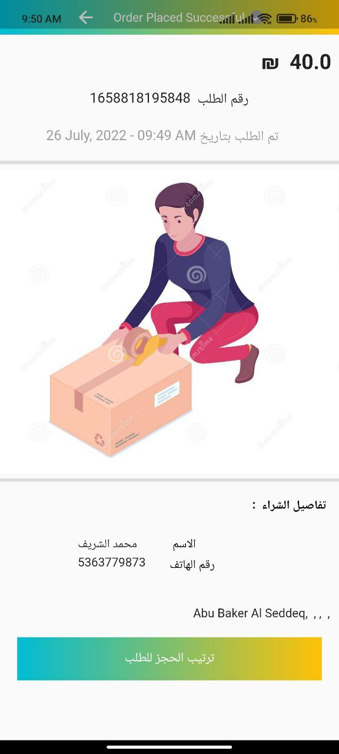

**Figure 4.5.3.15: Order processing**

When you click on any request, the following screen appears, which contains the request and user data.

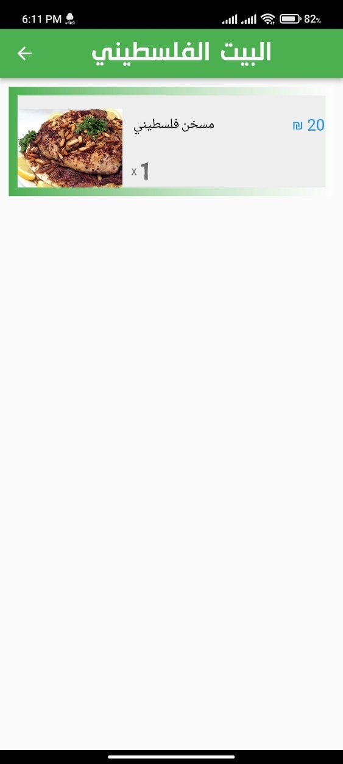

**Figure 4.5.3.16: Archived order**

When you click on archived requests, the requests that have been delivered to the user will appear.

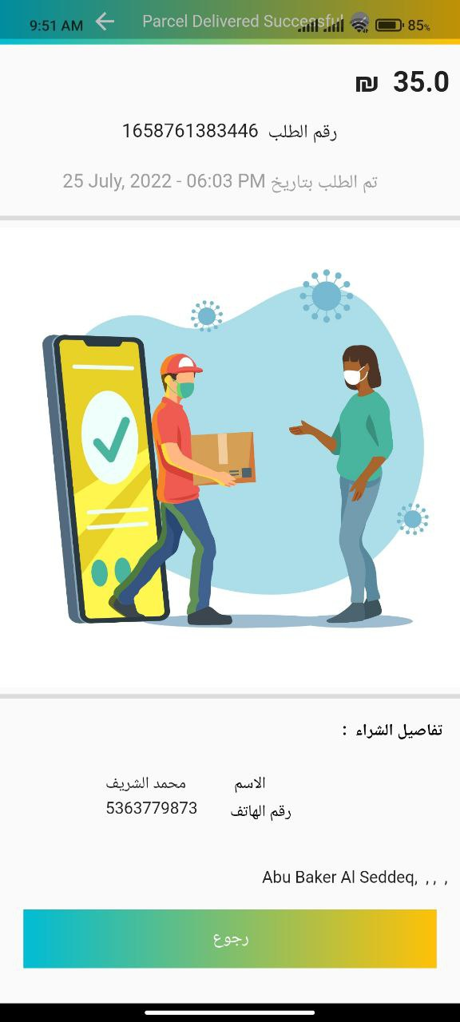

**Figure 4.5.3.17: Archived Order**

When you click on any request, the following interface appears, which displays the data of the request sent to the user.

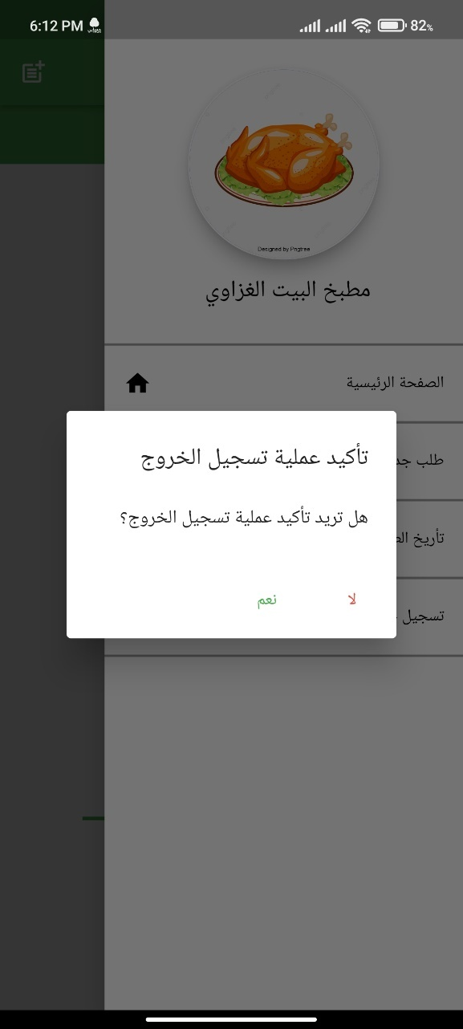

**Figure 4.5.3.18: Seller Log out**

And in the end, when the seller wants to log out, he clicks on the “Logout” option, the following message appears and confirmation is made in order to exit the application.

**4.5.4 Delivery results**

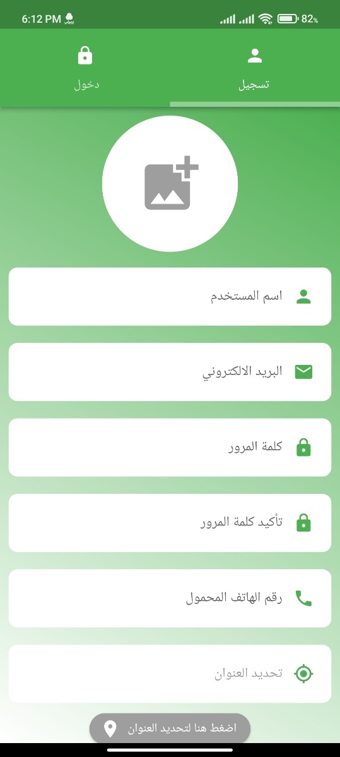

**Figure 4.5.4.1: Delivery Registration**

In this interface, the delivery service creates its own account and adds its personal data according to the existing fields. It also locates it automatically by clicking on the address specifying button and clicking on the word “Register”.

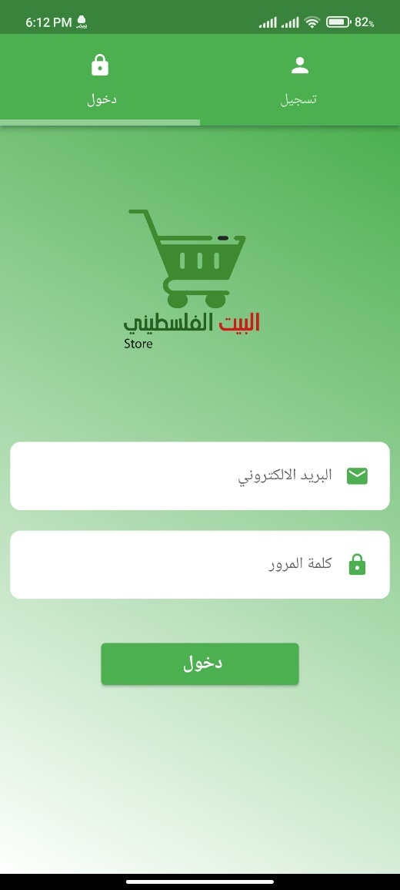

**Figure 4.5.4.2: Delivery sign on**

Here, after the delivery person creates his account on the application, then he goes to the login interface, he logs into the application through his email and password.

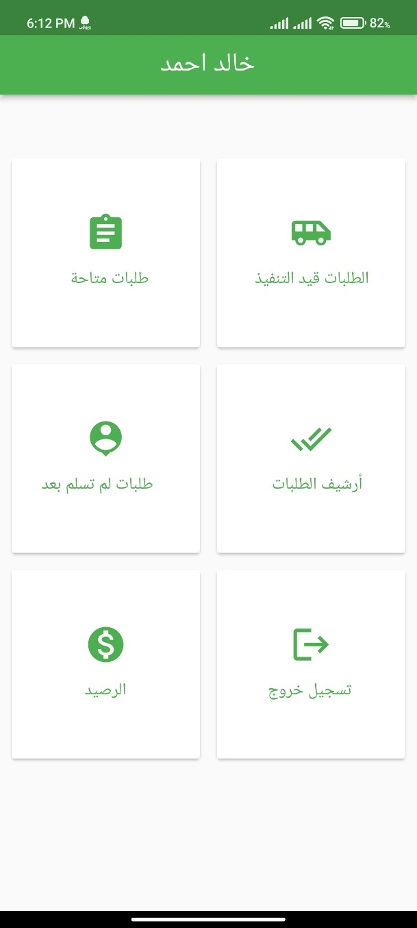

**Figure 4.5.4.3: Delivery Main Interface**

After logging in, the main interface of the delivery appears and contains several tasks as shown in the image.

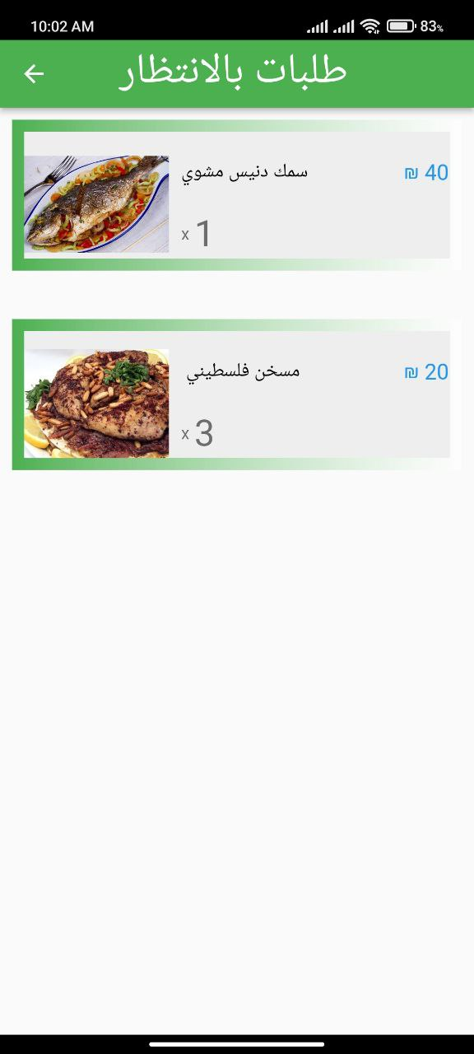

**Figure 4.5.4.4: Available Order**

When you click on the Available Requests option, the orders that have been processed by the seller are displayed for the delivery service to receive and deliver to the user.

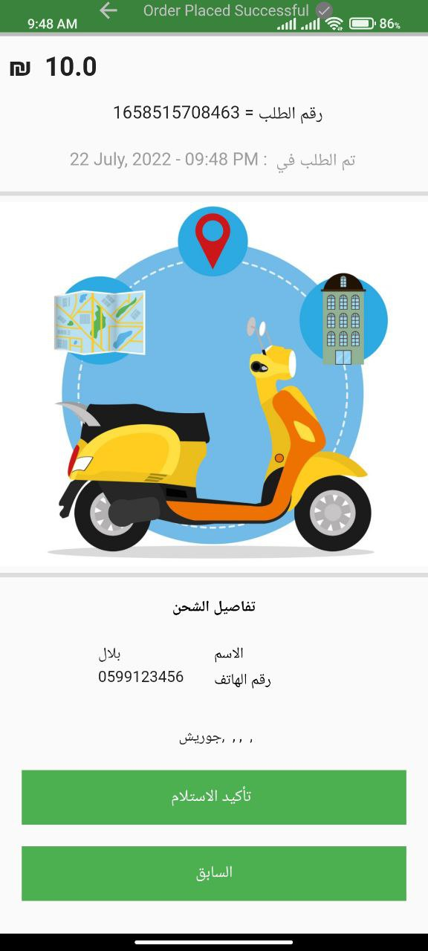

**Figure 4.5.4.5: Receipt of the order**

When you click on one of the available requests, a page will be displayed bearing the product price, the order number and the location of the user to whom the order is to be delivered, and the confirmation of receipt is pressed, to confirm that the delivery has received the order from the seller.

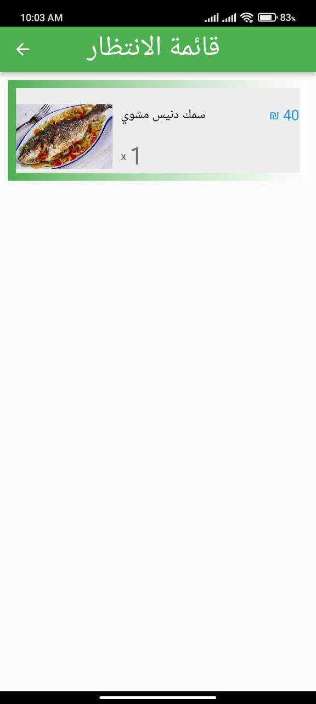

**Figure 4.5.4.6: waiting order**

After pressing the confirmation of receipt, the order is transferred to the “Requests in Progress” option, so that the delivery begins the process of delivering the order to the user.

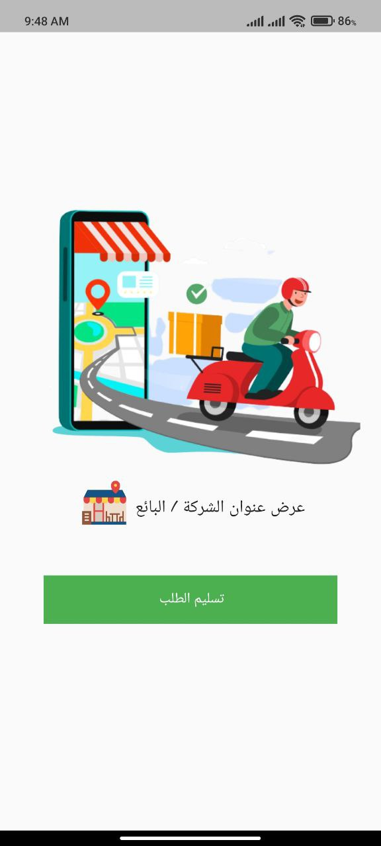

**Figure 4.5.4.7: order in the way**

When you click on the order in the “Requests in Progress” option, the following interface is displayed in order to move the order to the actual delivery stage, and a list of orders that have not yet been delivered will be transferred.

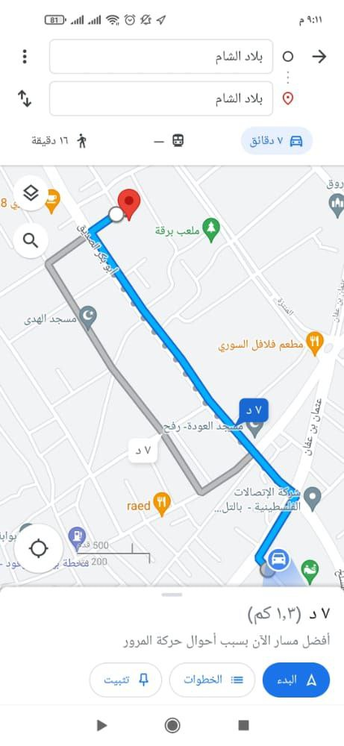

**Figure 4.5.4.8: Delivery path in Map**

In the previous interface, when you click on Show the address of the company / seller, a map is shown on which the path or method of access is located between the address of the seller and the user.

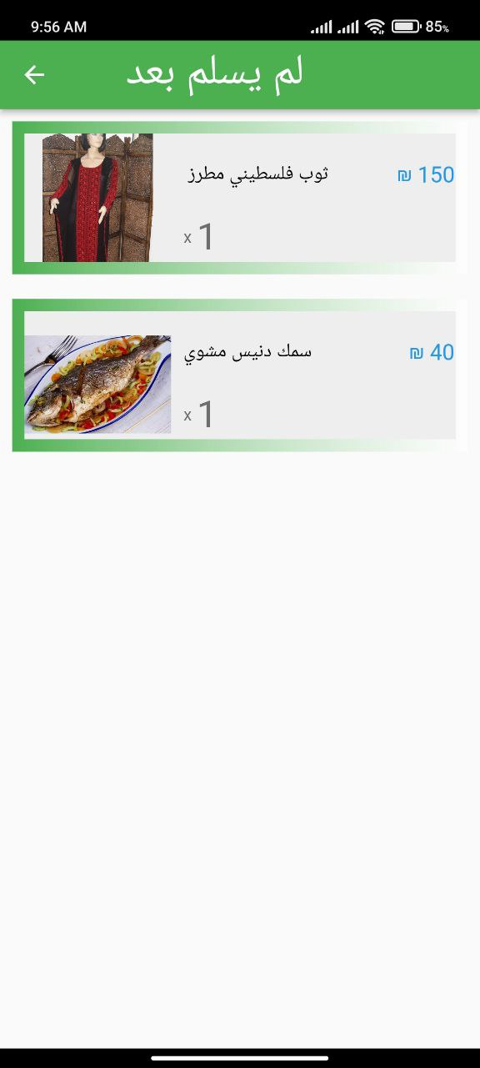

**Figure 4.5.4.9: Order not Delivered**

In the Orders not Yet Delivered option, it displays the products that have been delivered by the delivery but have not yet been delivered.

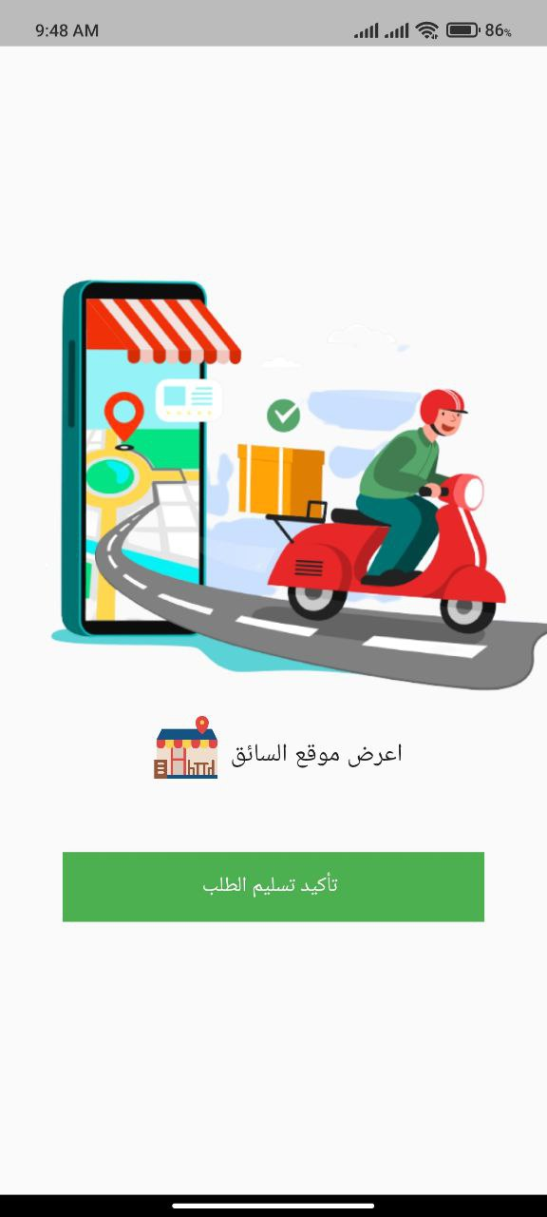

**Figure 4.5.4.10: order delivery**

When you click on one of the orders in the previous interface, this interface appears so that when the delivery arrives to the user and delivers the order, he presses the order delivery confirmation button to move the order to the order archive option that contains the orders that have been delivered to users.

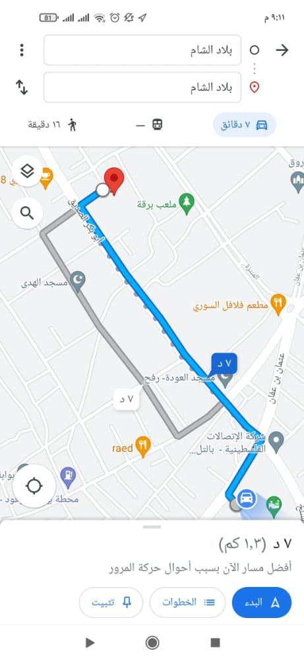

**Figure 4.5.4.11: Delivery way in Map**

In the previous interface, when you click on displaying the location of the delivery, a map appears with a tracked path used by the delivery in order to reach the user, and this path decreases little by little as the delivery approaches the user’s location.

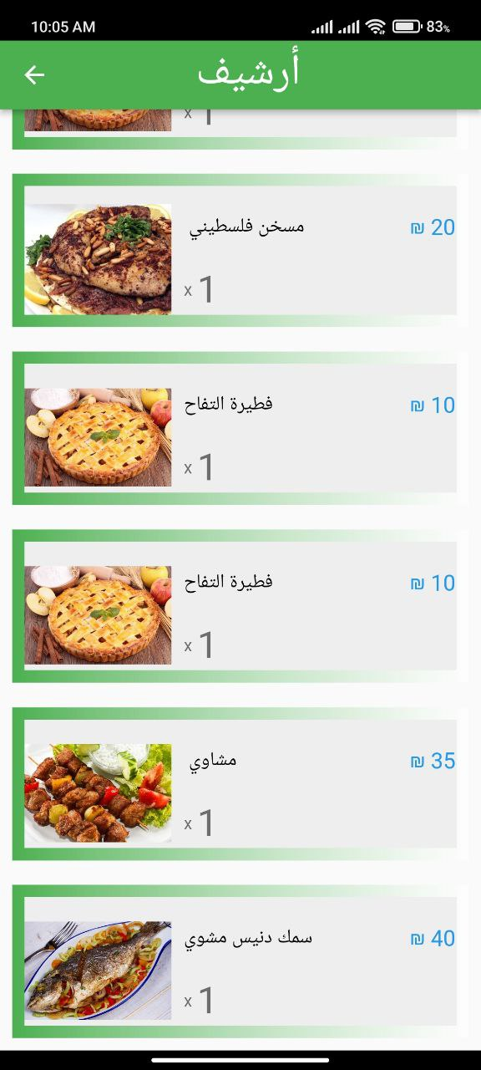

**Figure 4.5.4.12: Archive order**

In the Order Archive option, the orders that have been delivered to the user are shown.

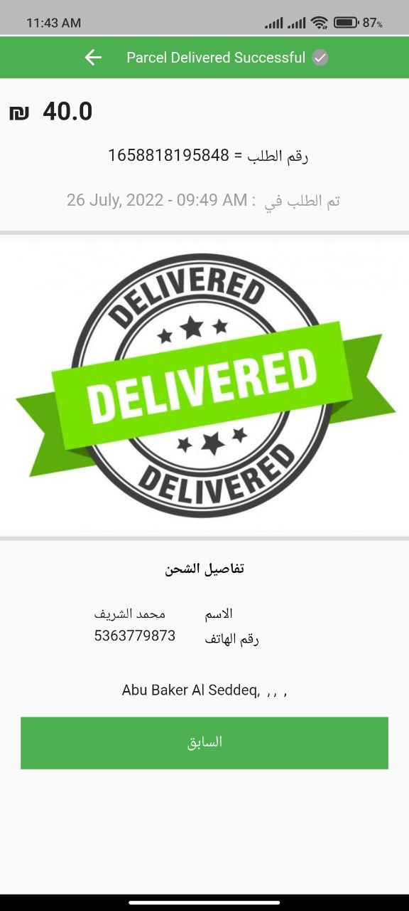

**Figure 4.5.4.13: Order Delivered**

When you click on one of the orders in the previous interface, the current interface appears that displays the price of the order, its number and user data as well.

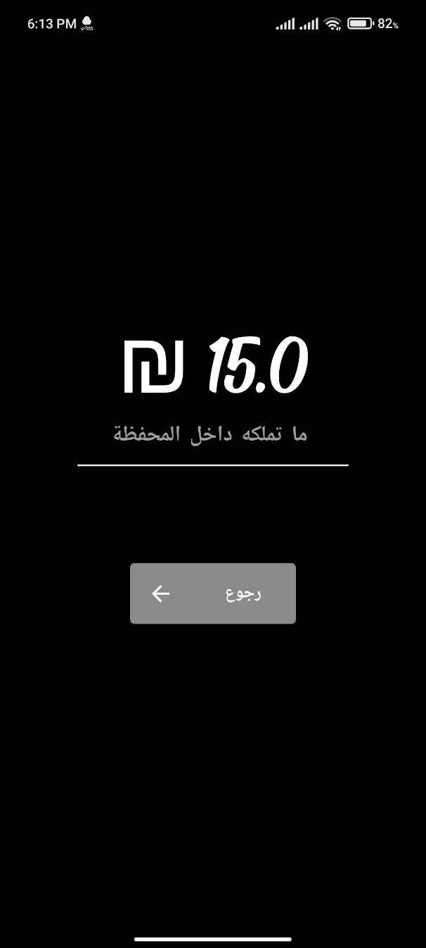

**Figure 4.5.4.14: cash balance delivery**

When you click on the balance option, the following interface appears showing the total balance of the delivery price for all orders, and the delivery price for the order has been agreed upon, which is 5 shekels per order.

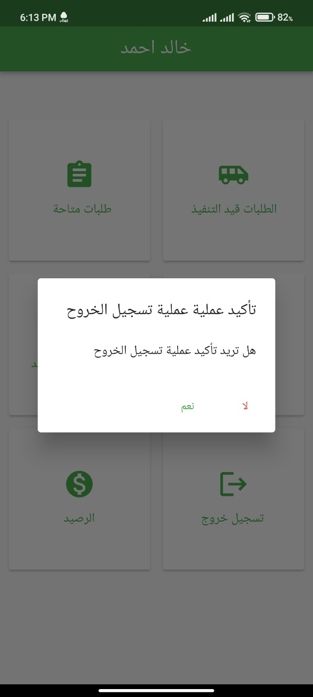

**Figure 4.5.4.15: Delivery Log out**

And in the end, when the deliveryman wants to log out of the application, he clicks on the option to log out and confirm it, and thus he has exited from his account on the application.

**4.5.5 Application control panel:**

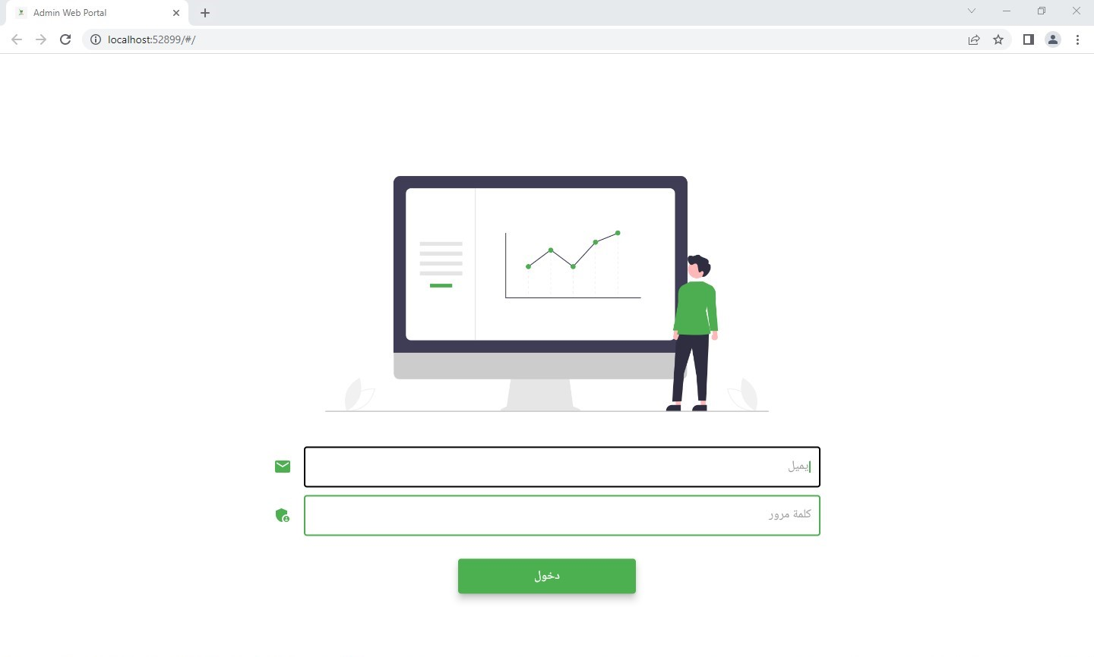

**Figure 4.5.5.1: Admin log in**

In this interface, the admin logs into the application’s web control panel by entering the email and password, and admin accounts are created and added to Firebase directly so that the admin has absolute control over the application.

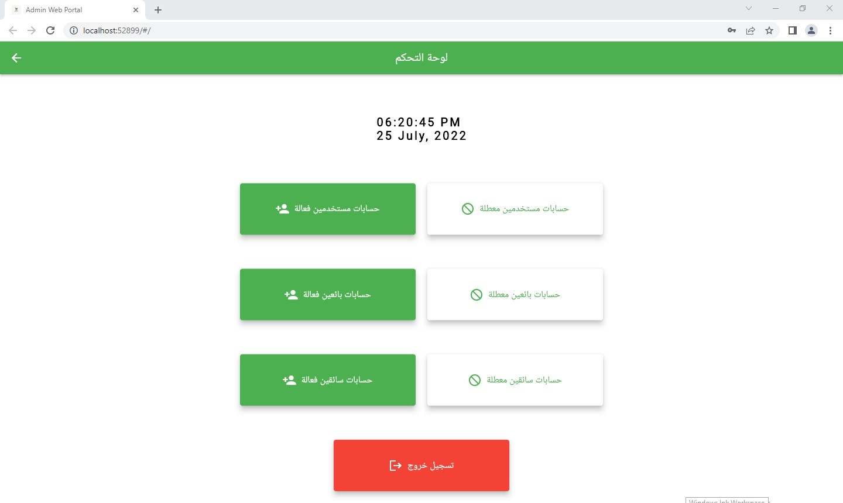

**Figure 4.5.5.2: Control panel web main Interface**

After logging in to the control panel, we go to the main page, we are shown the following options. The admin controls the accounts of users, vendors and delivery so that they activate and deactivate these accounts according to certain terms and conditions.

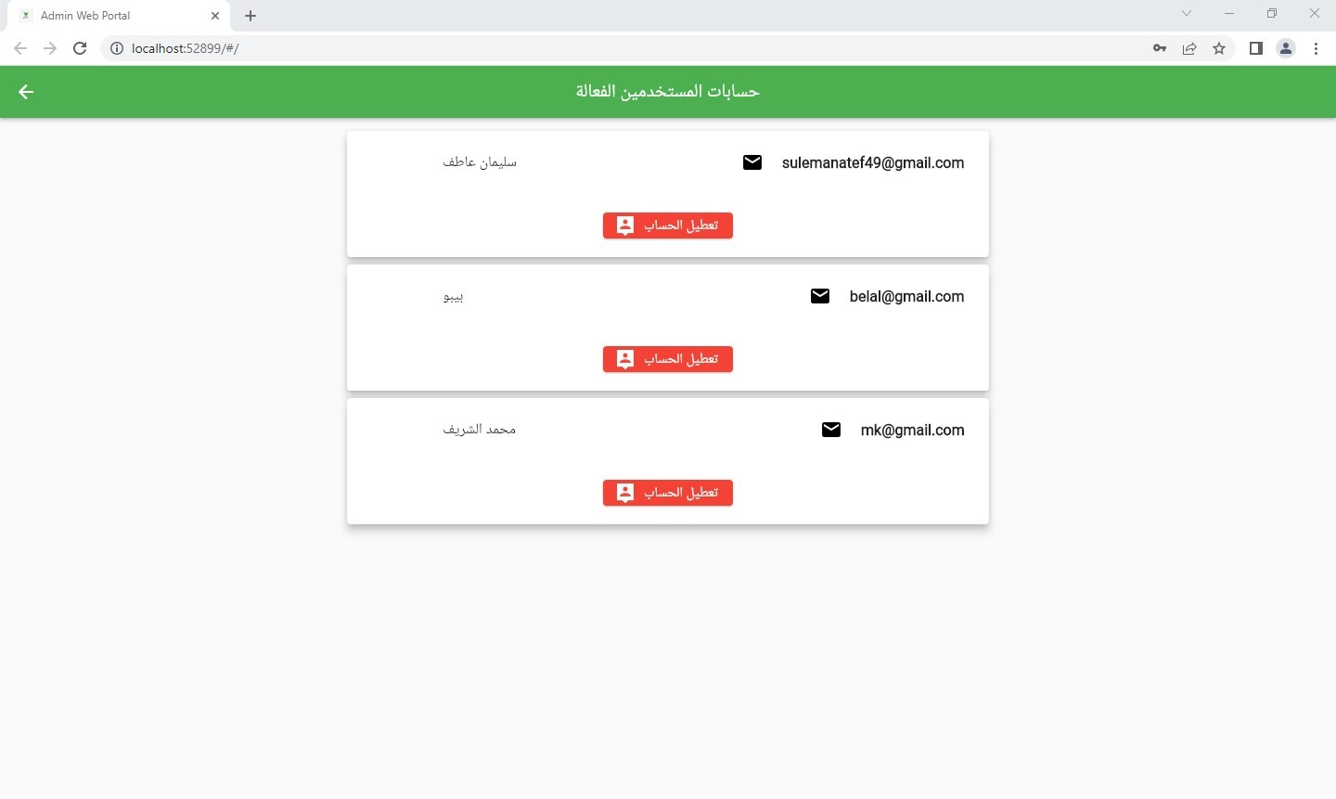

**Figure 4.5.5.3: Active user account**

When on the active user accounts option, an interface appears that displays all the active accounts of the users of the application, and through this interface, the admin has the ability to disable any account and move to the inactive accounts box.

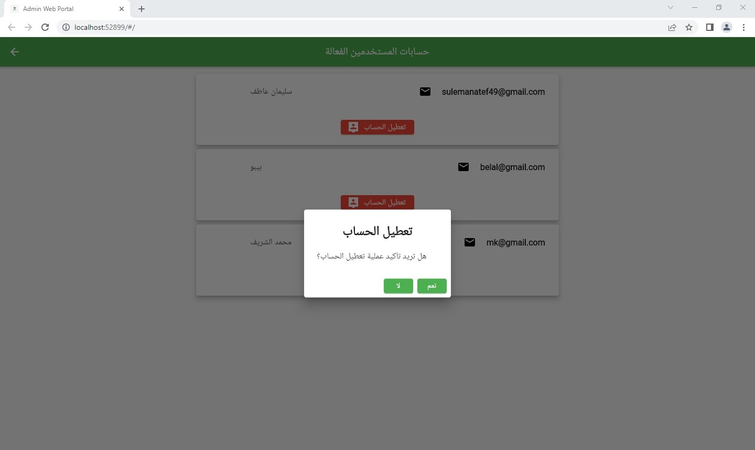

**Figure 4.5.5.4: disable user account**

Here it is confirmed that the active account is disabled.

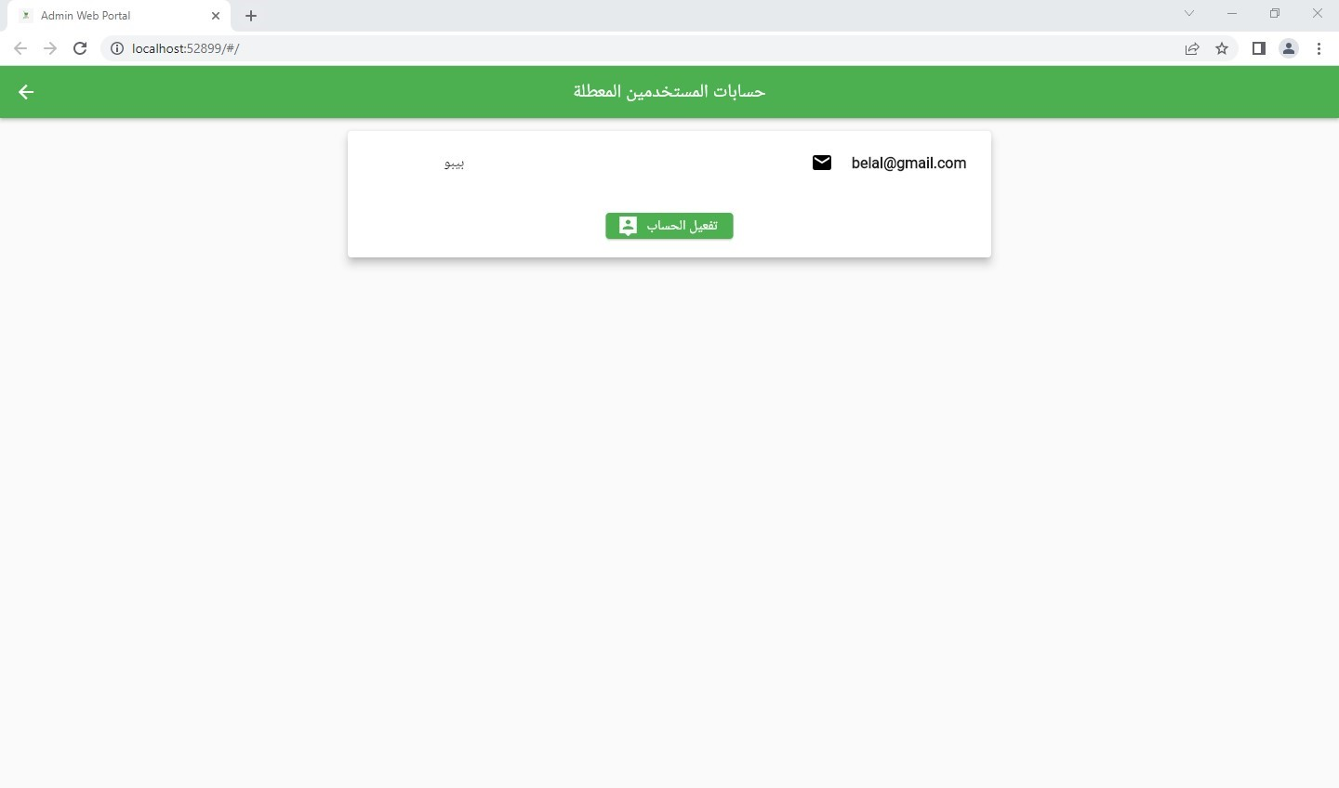

**Figure 4.5.5.5: User disable Account**

In the Disabled User Accounts field, the accounts that have been disabled by the admin appear and he can reactivate those accounts.

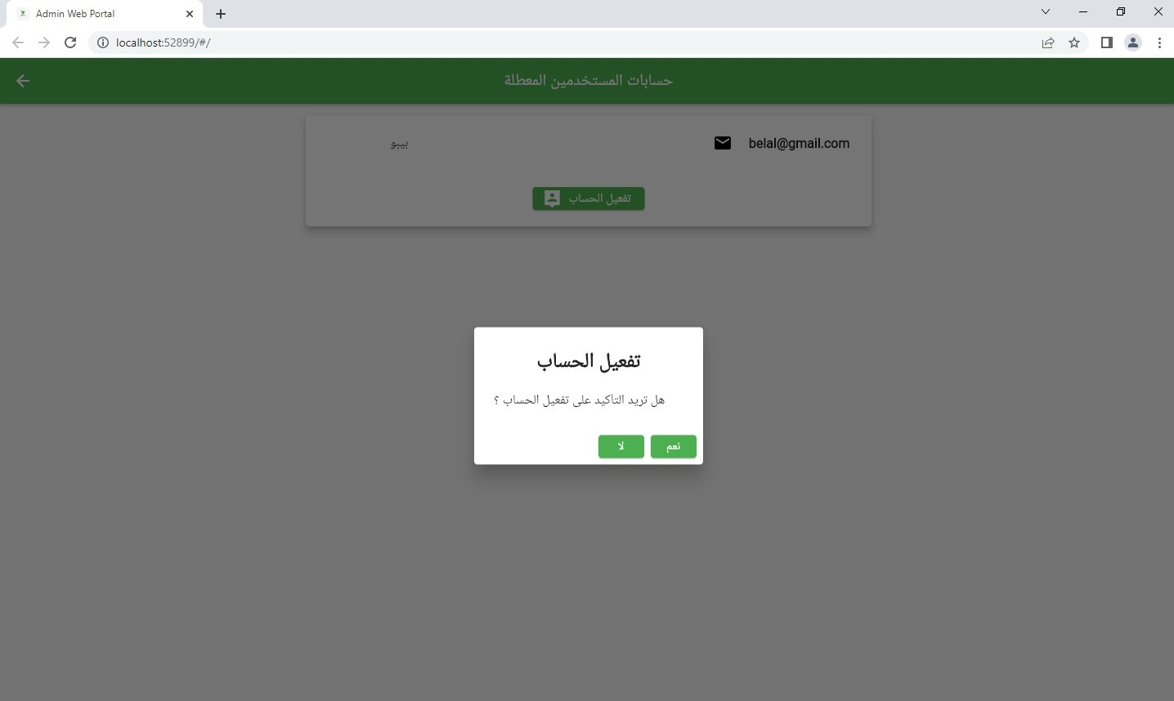

**Figure 4.5.5.6: Active user account**

Here, the account is confirmed

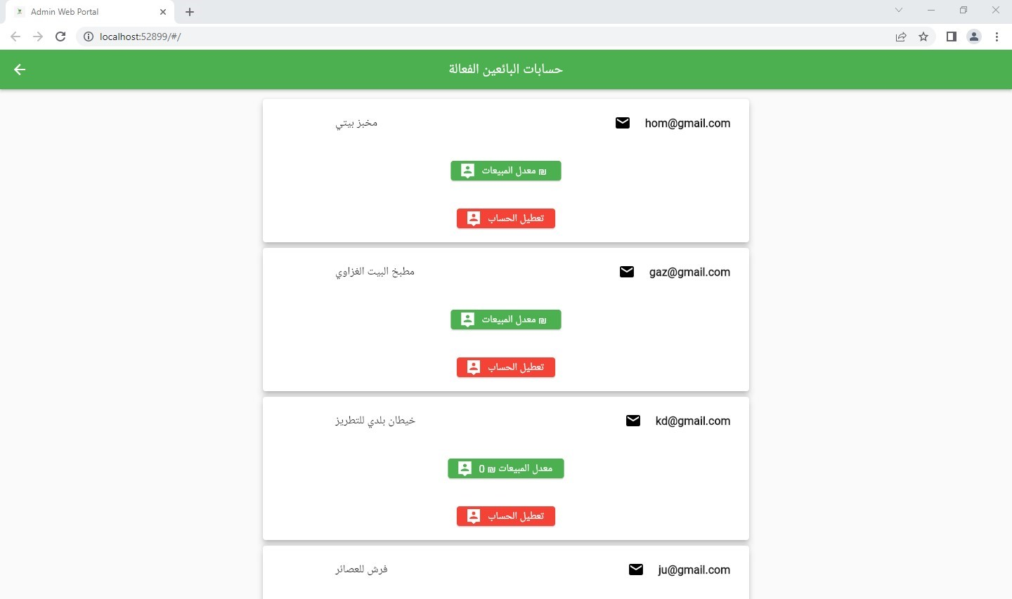

**Figure 4.5.5.7: Active seller Account**

When on the option of active seller accounts, an interface appears that displays all the active accounts of the sellers of the application, and through this interface, the admin has the ability to disable any account and move to the inactive accounts box.

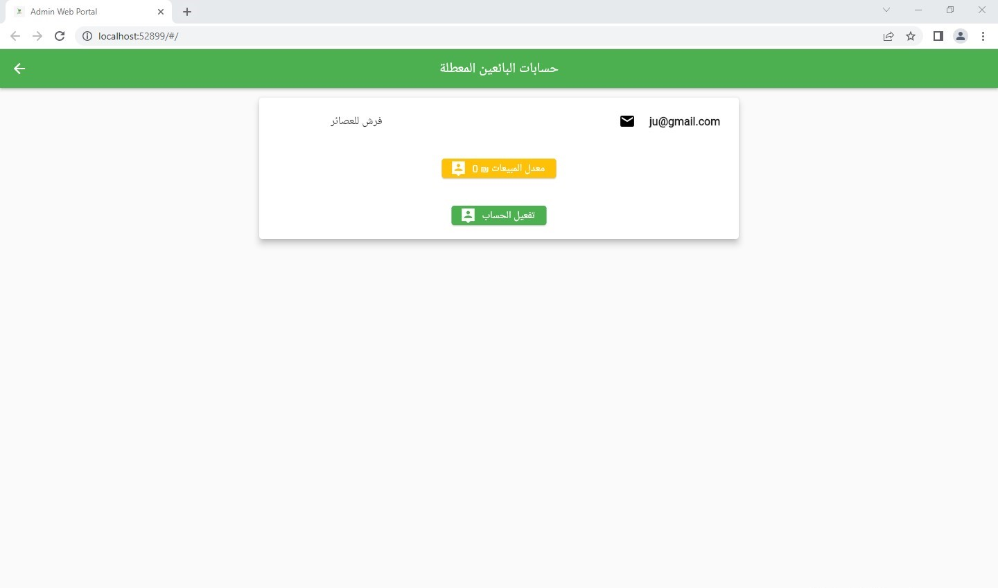

**Figure 4.5.5.8: disable seller account**

In the Disabled Seller Accounts field, the accounts that have been disabled by the admin appear and he can reactivate those accounts.

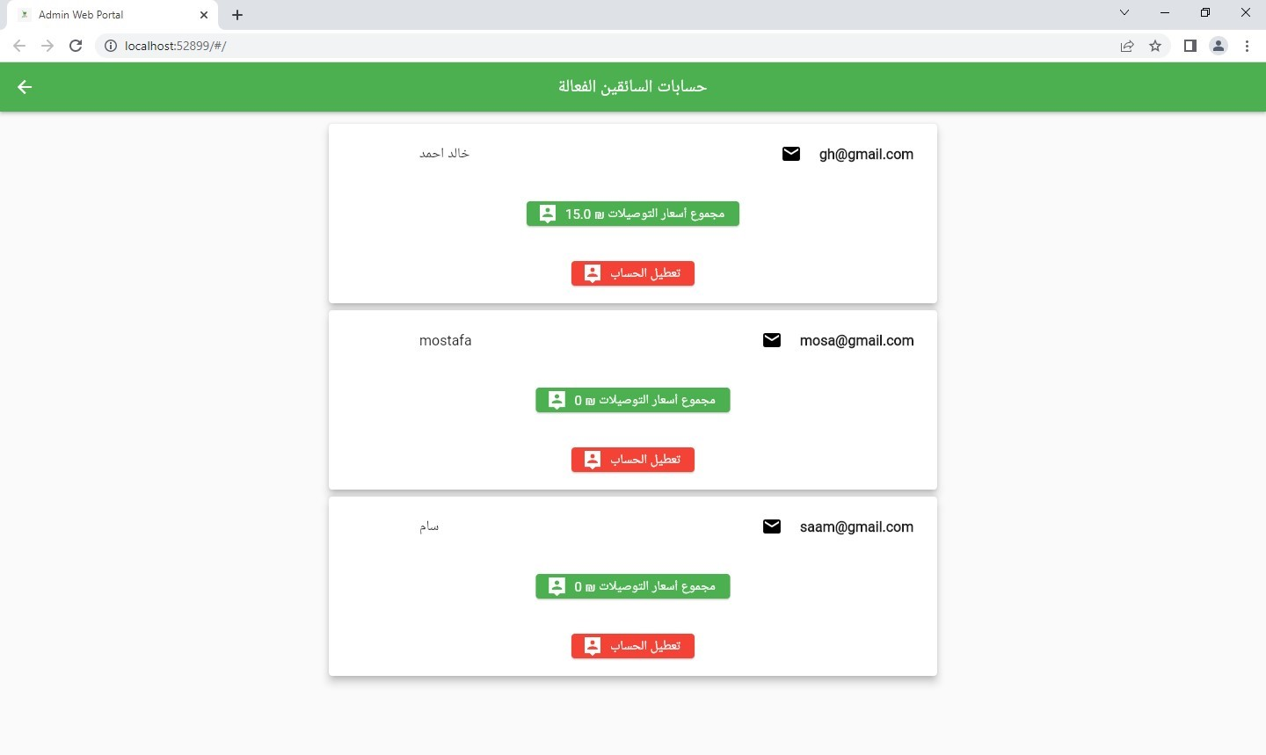

**Figure 4.5.5.9: Delivery active account**

When on the active delivery accounts option, an interface appears that displays all the active accounts of the delivery of the application, and through this interface, the admin has the ability to disable any account and moves to the inactive accounts box, and also shows the balance of each of the delivery accounts.

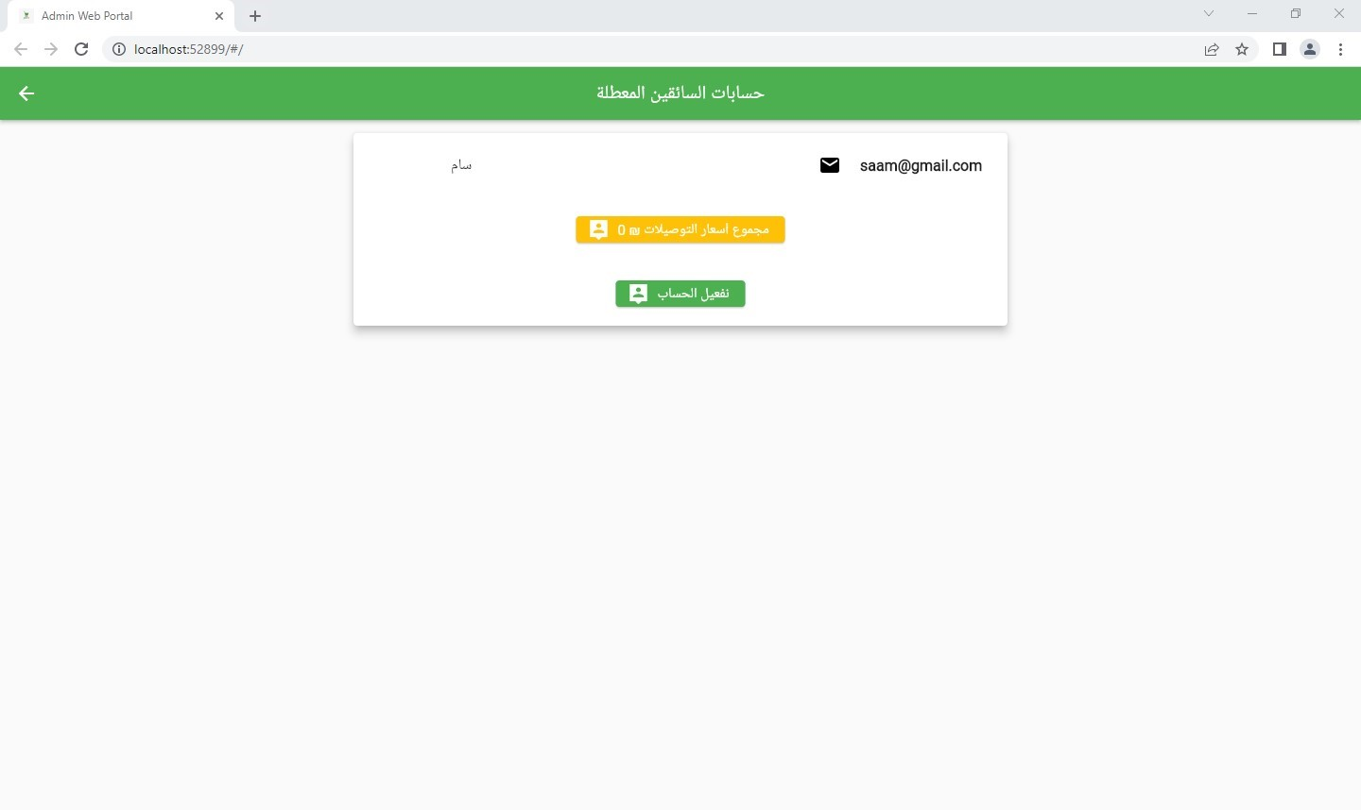

**Figure 4.5.5.10: disable Delivery account**

In the Disabled Delivery Accounts field, the accounts that have been disabled by the admin appear and he can reactivate those accounts.

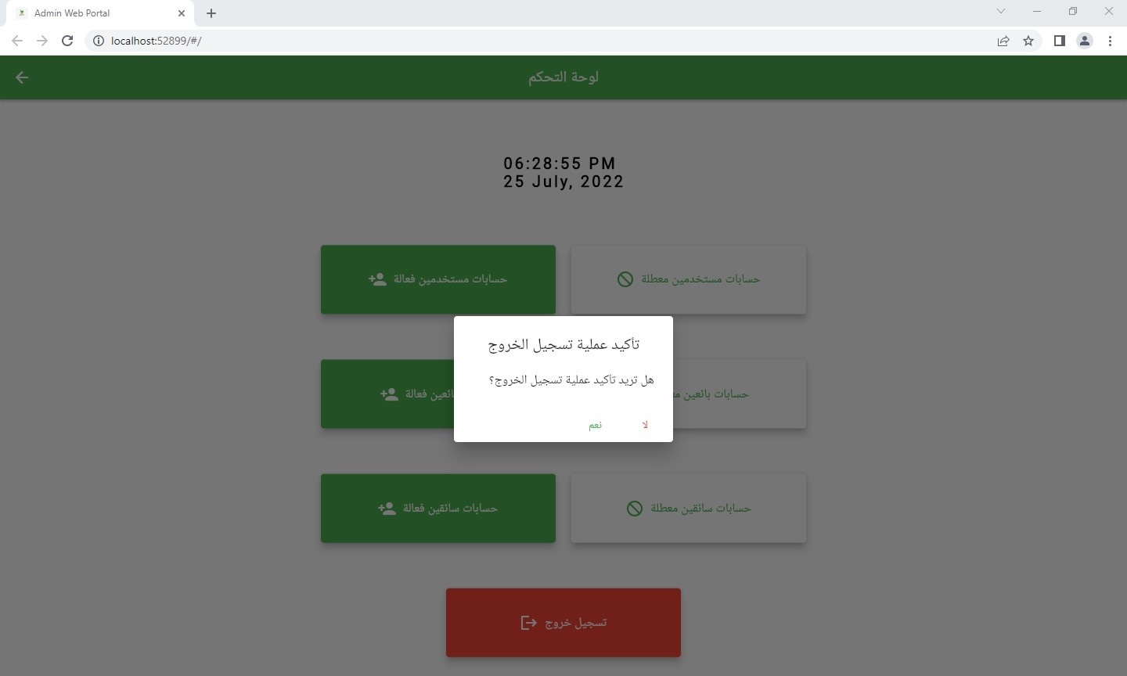

**Figure 4.5.5.11: Admin log out**

When you click on logout, the admin confirms that you are logged out from the web control panel

## **4.6 Summary:**

In this chapter, we explained an introduction to the chapter and explained in detail about the system models. We also analyzed the system using schematics and did a test for it and in the end we presented the final results of the system.

**Chapter 5**

**Results and Discussion**

## **5.1 Introduction:**

In this chapter, we will talk about the assumptions that will be used in the project, and we will also present the most important results that we have reached after the project experience.

## **5.2 Assumptions:**

In this project, the assumptions were divided into two parts:

1 - The Assumptions that have been worked out in the application.

2 - Assumptions proposed but not implemented.

* **The Assumptions that have been worked out in the application:**

There is a set of assumptionsthat he chose to work with, namely:

1- Pay in cash.

2- Using maps to determine the location.

3- Using the Firebase.

4- Project work is an application for mobile phones.

5- Create a control panel for the application.

* **Assumptions that have not been worked out:**

The following assumptionswere suggested for use, but were not used:

1 - Dark theme of the application.

2- Designing the project in the form of a website.

3- Payment method via credit card.

4- Establishing a team of delivery workers for the project.

5- Not setting a time indicator for the delivery of the order.

## **5.3 Evaluation:**

Here we will talk about the evaluation of the application was made with several people.

This assessment is divided into three sections:

1. Usability Evaluation.
2. Functional Evaluation.
3. Performance Evaluation.

1. **Usability Evaluation.**

Here we will ask several questions about the performance of the application,

and the questions will be evaluated from 5, the following table will contain

these questions:

|  |  |  |  |  |  |
| --- | --- | --- | --- | --- | --- |
| **Question** | **1** | **2** | **3** | **4** | **5** |
| Does the app work smoothly? |  |  |  | * |  |
| Are the functions of the application working well? |  |  | * |  |  |
| Is the app difficult to use? | * |  |  |  |  |
| Is the design of the application friendly? |  |  |  | * |  |
| How does the application interact? |  |  | * |  |  |

**Table 5.3.1: Usability Evaluation.**

* The following chart shows the average rating for each of the questions in the previous table.

**Figure 5.3.1: Usability Evaluation.**

1. **Functional Evaluation:**

The following table displays the evaluation of the following application functions:

|  |  |  |  |
| --- | --- | --- | --- |
|  | Question | Yes | No |
| Add Function | add products | * |  |
| add users |
| Add sellers |
| Add Delivery |
| Add location coordinates |
| Retrieve Function | Retrieve Order Money | * |  |
| Retrieve Delivery money |  | * |
| Delete Function | Delete Order | * |  |
| Delete item list |
| Delete item |

**Table 5.3.2: Functional Evaluation.**

1. **Performance Evaluation:**

In this part, we will display a table to show the duration of the application's performance in some functions:

**Table 5.3.3: Performance Evaluation.**

|  |  |
| --- | --- |
|  | Time in second |
| add products | 10 – 15 |
| add users | 20 – 30 |
| Add sellers | 20 – 30 |
| Add Delivery | 20 – 30 |
| Add location coordinates | 5 – 8 |
| Add item list | 12 - 20 |
| Add item | 15 - 25 |

## 

* The following table presents the performance evaluation and the difference between our own system and other systems:

|  |  |  |
| --- | --- | --- |
|  | Current system | Our solution |
| time | 12 hour – 1 Day | 2 – 5 hours |
| Fraud | High | Low |
| security | Middle | High |
| Location in map | mostly not | Existing |
| return order | mostly not | Existing |

**Table 5.3.4: Performance Evaluation.**

## **5.4 Summary:**

In this chapter, we explained an introduction to the chapter and explained the hypotheses that were used in the application, and we also made an evaluation from several aspects of the application.

**Chapter 6**

**Conclusions, Recommendation and Future Work**

# **6.1 Introduction:**

In this chapter, we will present some of the recommendations that have been selected, and also present some future work that may be done, and in the end, the project conclusions will be addressed.

## **6.2 Recommendations:**

Here we will present some of the following suggested recommendations:

1. Expand the geographical area covered by the application.

2- Making discounts for active and most requested customers through the

application.

3- Add some conditions to the use of the application.

## **6.3 Future business:**

The following are some of the future works that may be applied to the project:

1. Expand the application to include stores, companies, etc.
2. Adopting new items in the application, such as household and electrical

appliances, and imported clothes.... etc.

1. The possibility of creating a delivery team for the application.
2. Support for applications in other languages.
3. Adding a rating for the sellers and adding comments to the users on the product.
4. Add notifications to the application.
5. The work of a support and inquiries team to receive complaints about the application.
6. Setting terms and conditions for the application.

## **6.4 Project conclusions:**

The Team made a project to implement a shop for the sale of household and handicrafts. The aim of this project was to support small projects and productive families in order to achieve a good financial return and improve their material and social conditions. In this report, which consists of i chapters, we explained and detailed the project and a problem was identified for the study and also We determined the importance and objectives of the project, and also explained the proposed system’s shape, mechanism of action, and the form that it would be. We also made plans showing the mechanism of the application’s work in its three sections (seller, buyer, and delivery worker), and we compared our project with other similar projects, mentioning their advantages and disadvantages. And we tested the application and verified the validity of its work. We also identified the hypotheses that the application will work with. We also reached the results achieved by the application. Finally, we made some recommendations and mentioned some future work that may be added to the application. In the end, our goal of this project was humanity. Before it becomes profitable, we ask God Almighty to grant success in it and in future business as well.

## **6.5 Summary:**

In this chapter, we explained an introduction to the chapter and explained the future work of the application and also presented some recommendations and in the end we made a comprehensive summary of the report.

**References**

1- Diagram draw website:

[. .\app_diagrams_default.html](../app_diagrams_default.html)

2- Flutter libraries website:

[..\pub_default.html](../functional-test.html)

3- Sanad website and application:

[..\snder_default.html](../snder_default.html)

1. Jumia Egypt website

<https://www.jumia.com.eg/>

1. **agile methodology source**

[..\ما-هي-منهجية-أجايل-للمبتدئين.html](../ما-هى-منهجية-أجايل-للمبتدئين.html)

1. **Aziz application page on Facebook**

[..\AzeezApp.htm](../AzeezApp.htm)

**Supplements**

|  |  |  |  |
| --- | --- | --- | --- |
| Symbol | Meaning symbol | symbol | Meaning symbol |
|  | Use Case |  | End |
|  | move arrows |  | resolution |
|  | Actor |  | start |
|  | Execution time |  | process |
|  | Database |  | Life line of operation sequence |

* icons

**Table 6.1: icons**